Tour ID: 249772  
Tour Name: Northern Europe Discovery: Iceland & Norway

Tour destinations: ['Reykjavik', 'Heimaey Island', 'Geiranger', 'Kristiansund', 'Reine', 'Lofoten', 'Leknes', 'Tromso']

Tour destinations images:

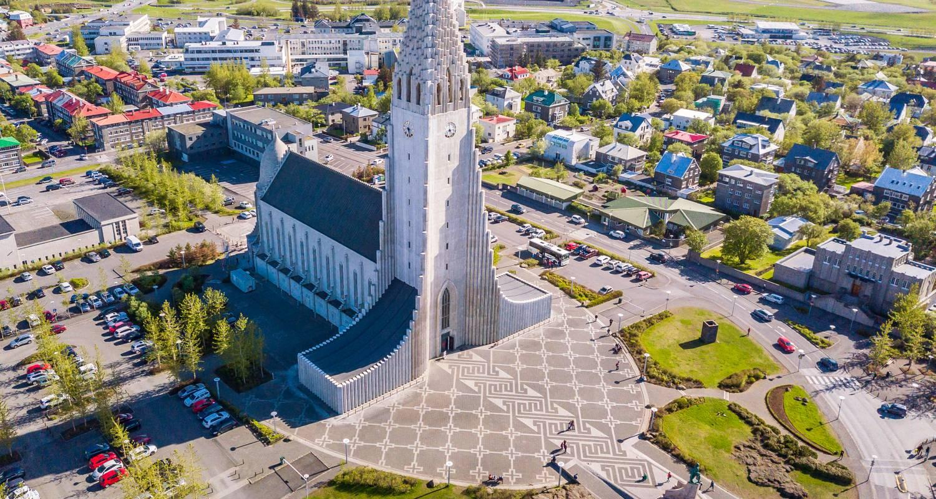

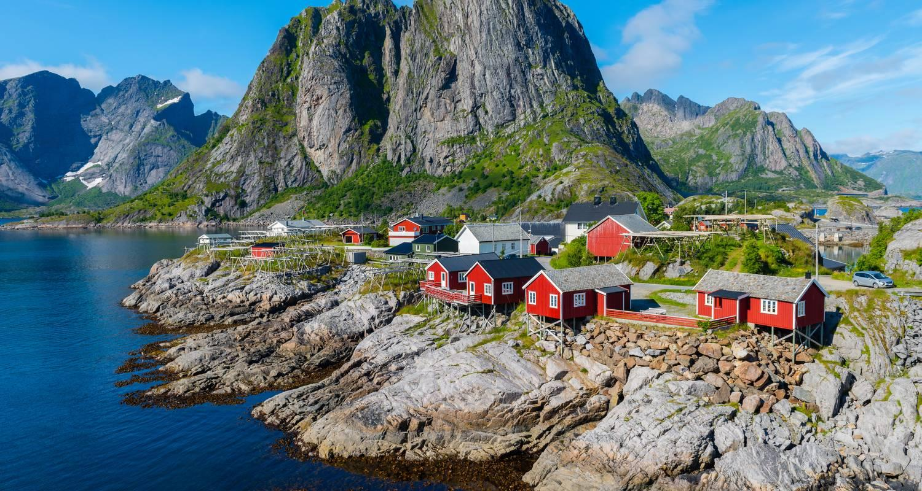

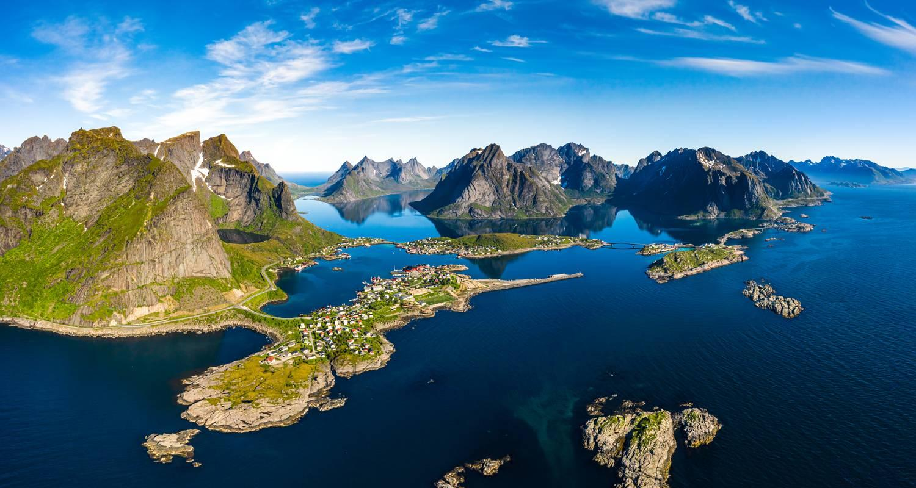

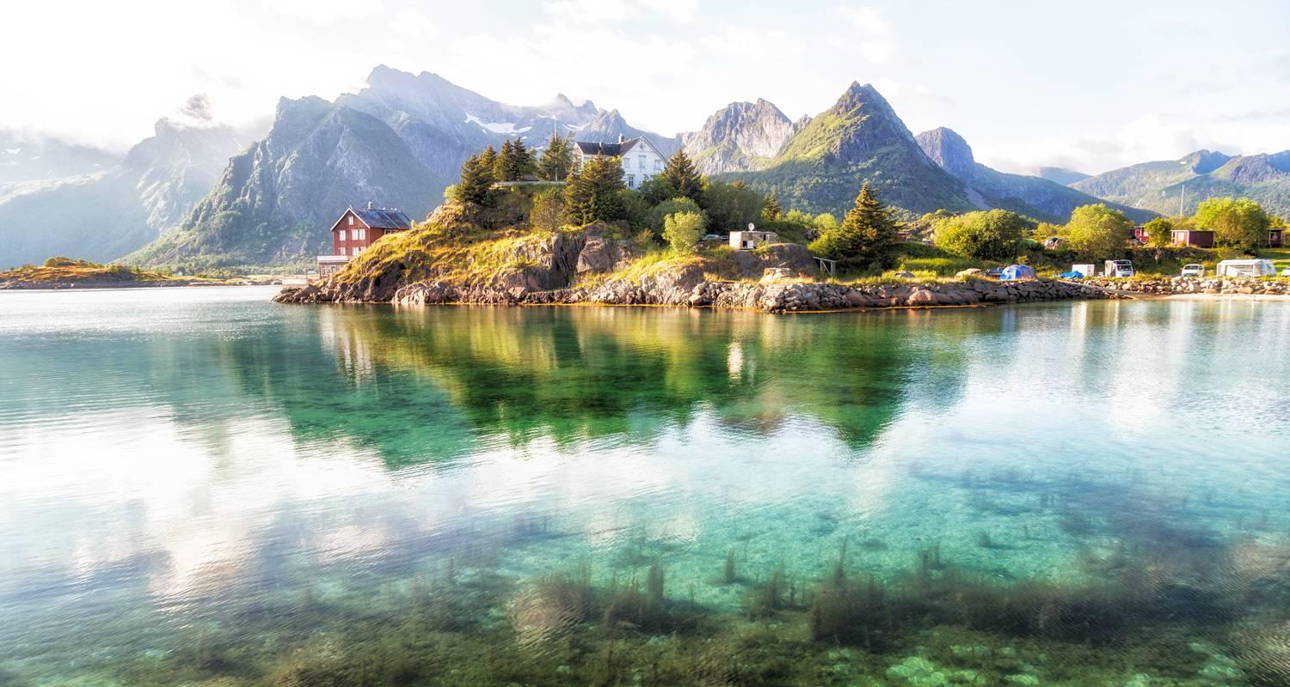

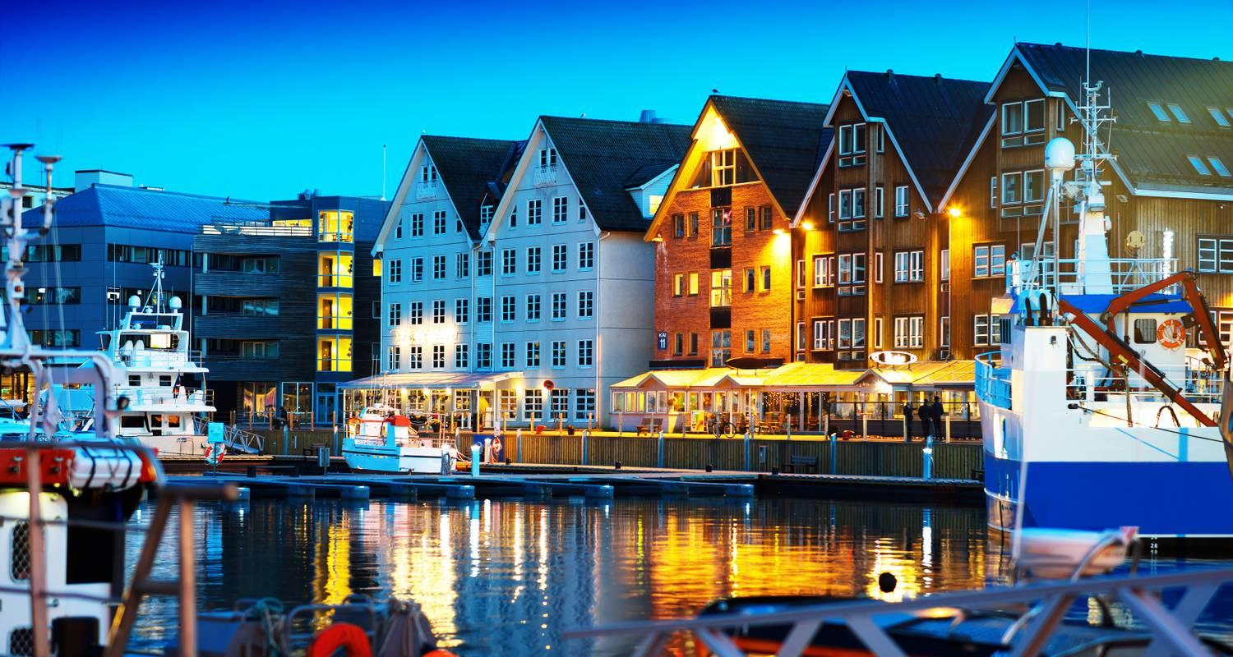

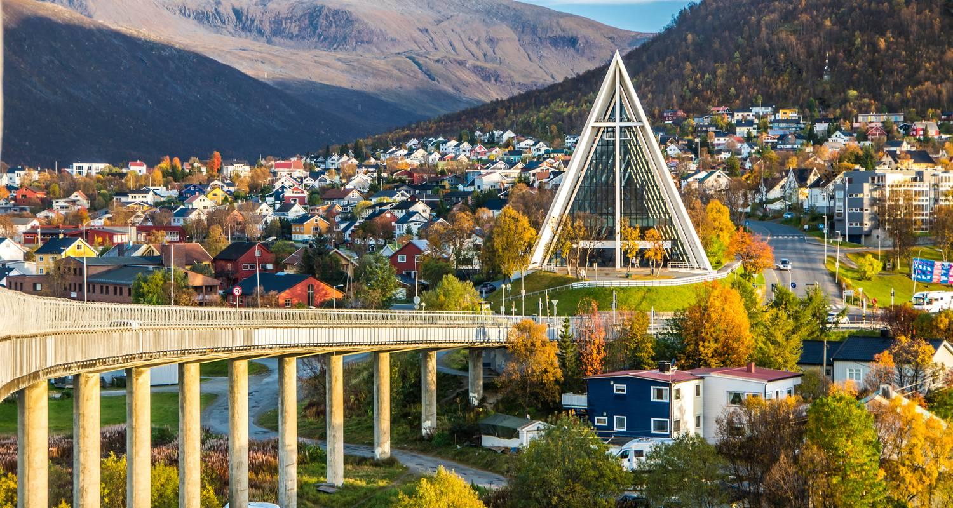

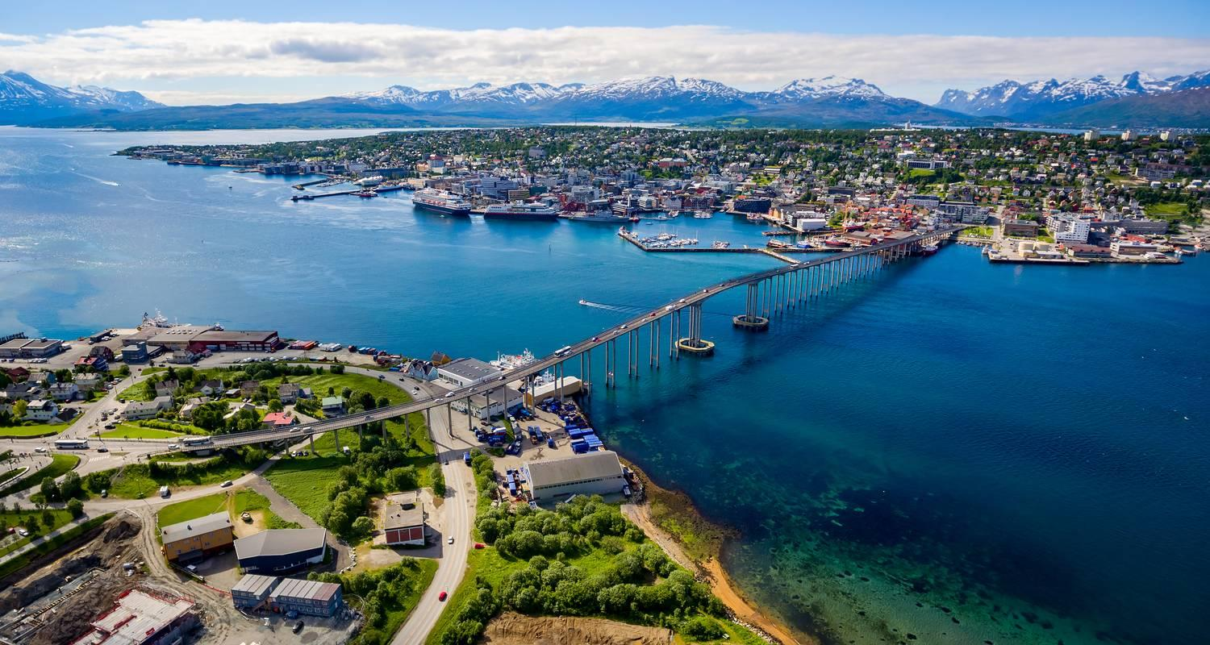

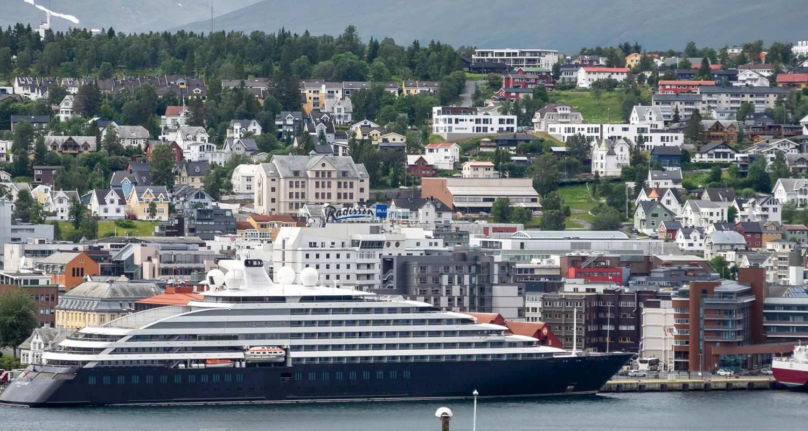

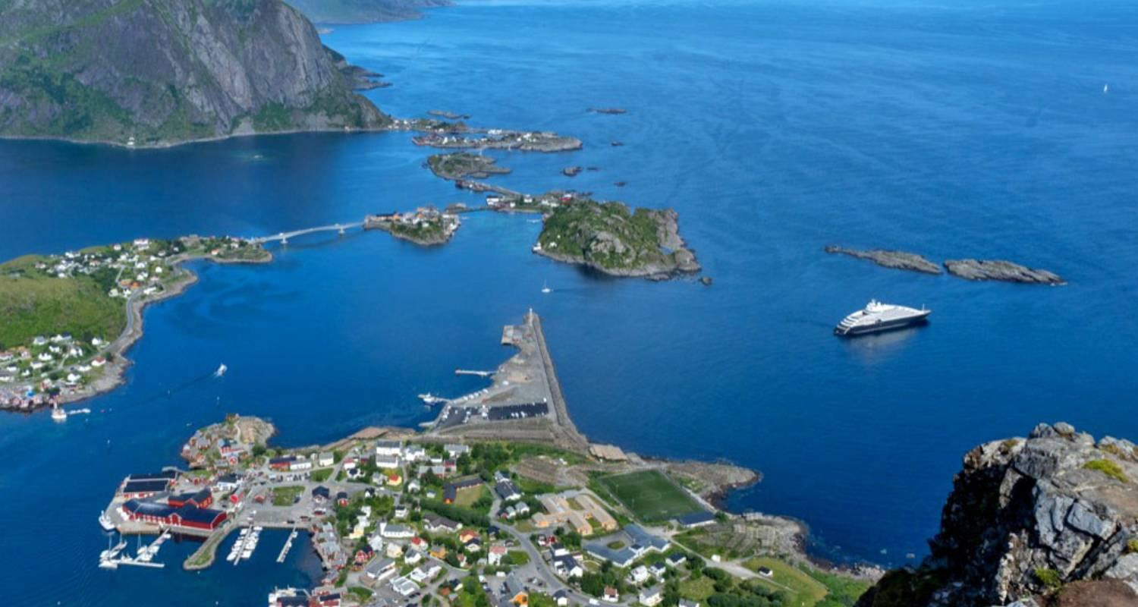

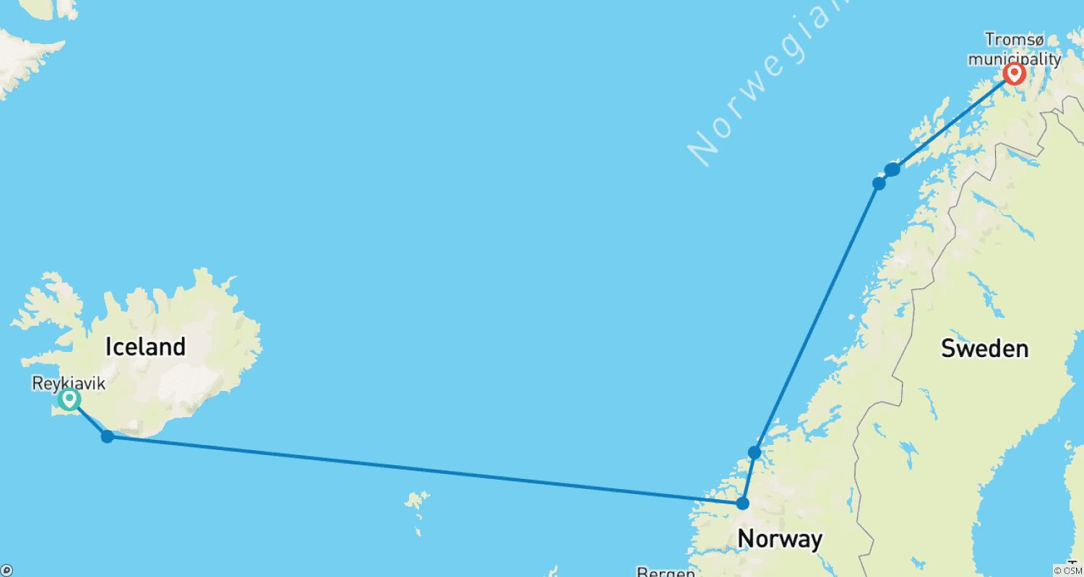

Tour ID: 249851  
Tour Name: Northern Europe Singles Cruise

Tour destinations: ['Southampton', 'Zeebrugge', 'Amsterdam', 'Bergen', 'Geiranger', 'Alesund', 'Akureyri', 'Isafjordur', 'Reykjavik']

Tour destinations images:

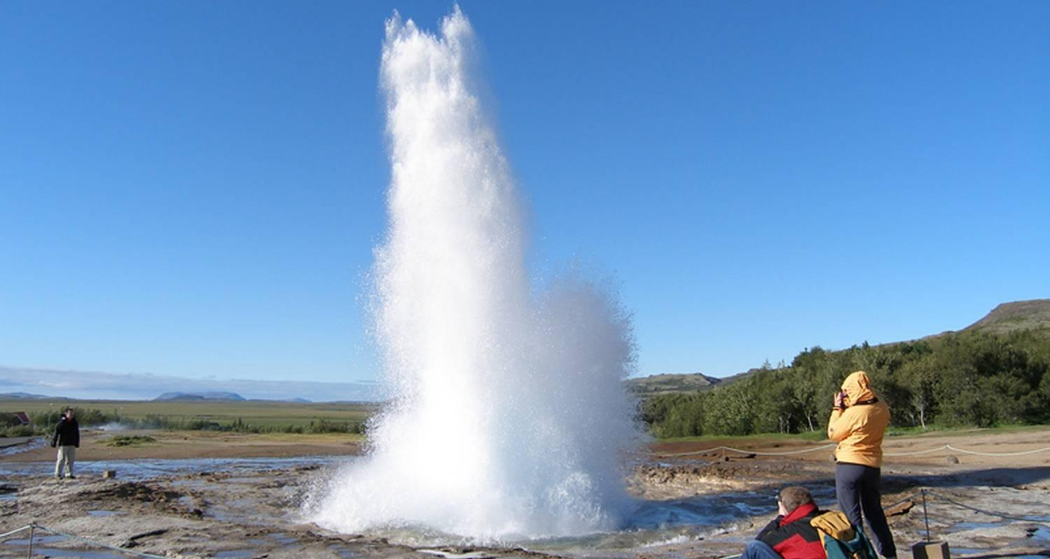

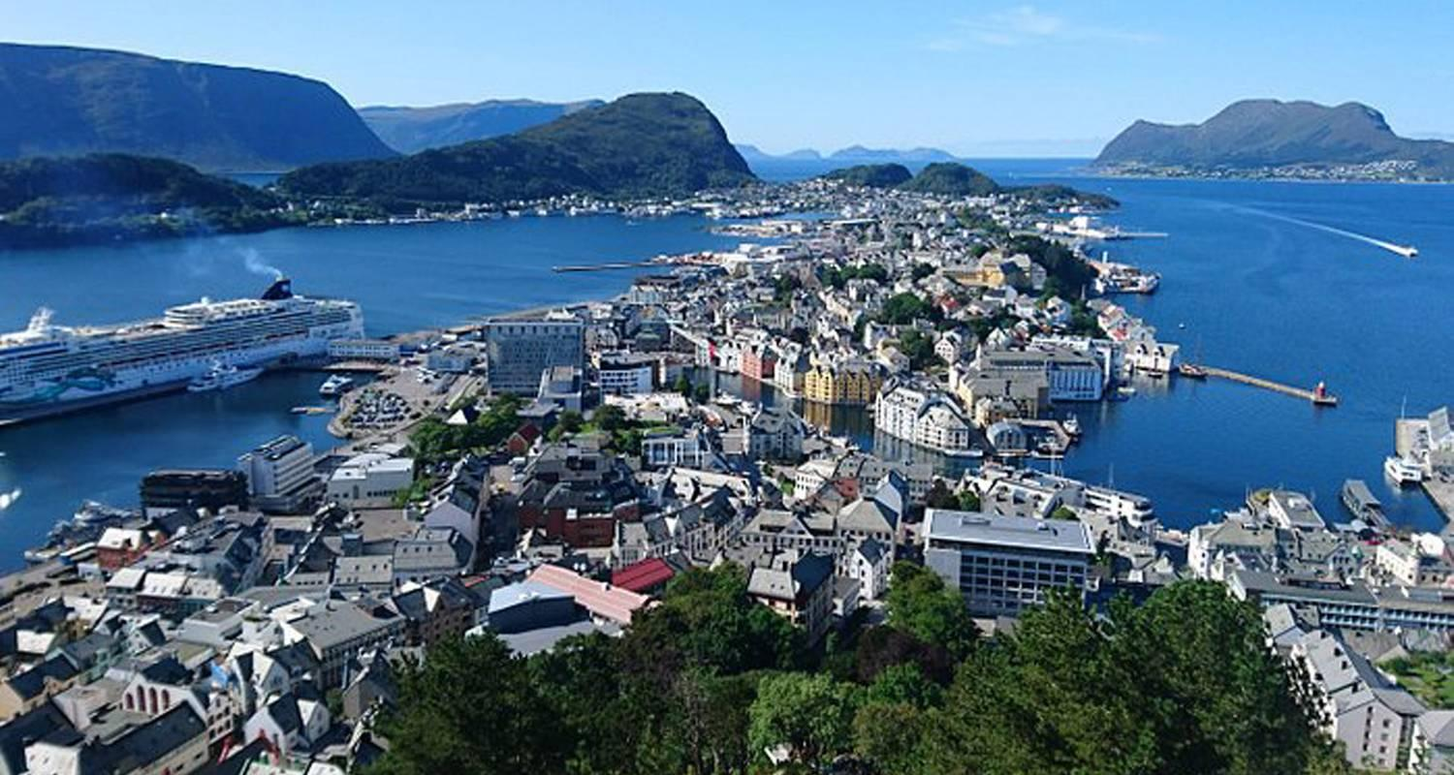

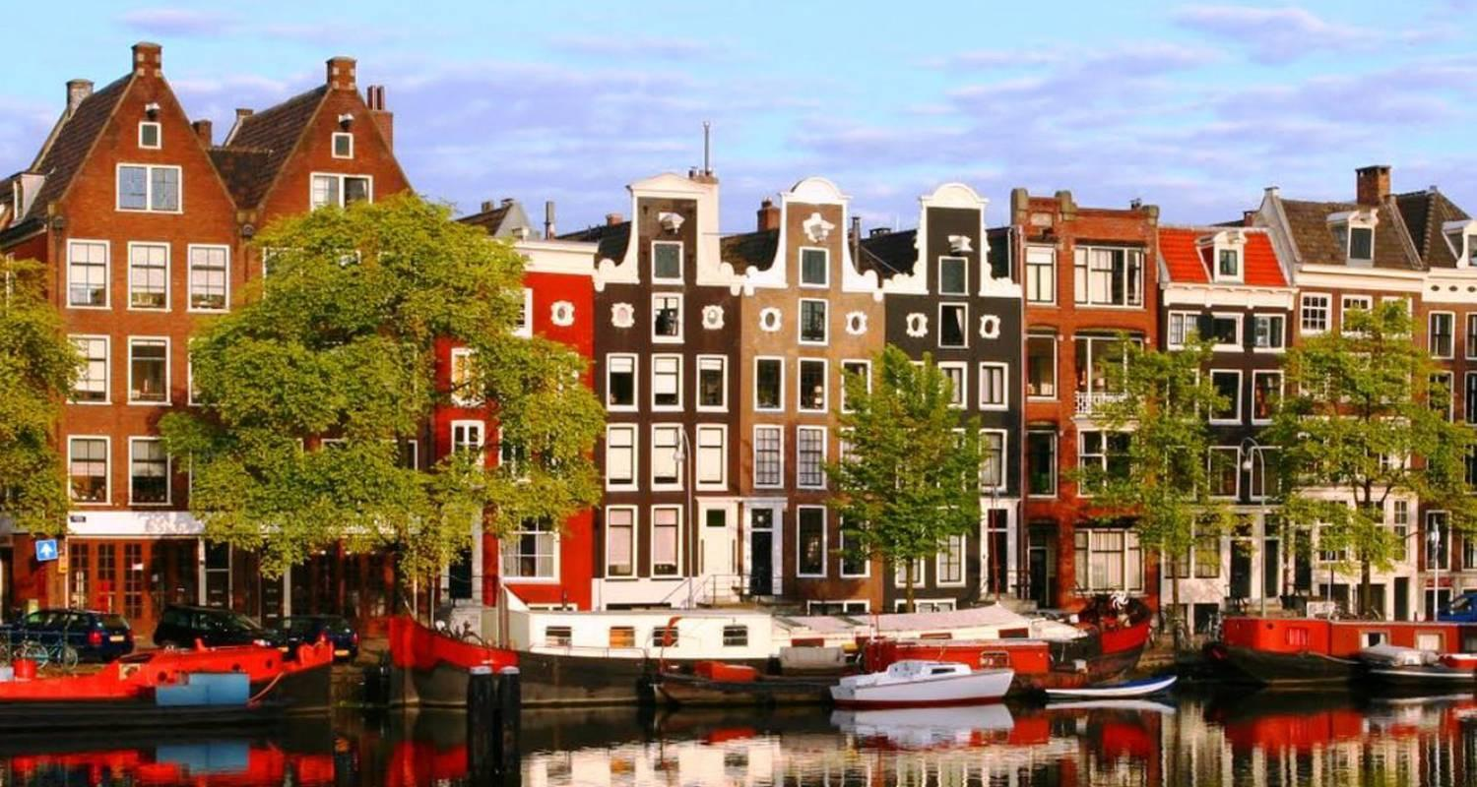

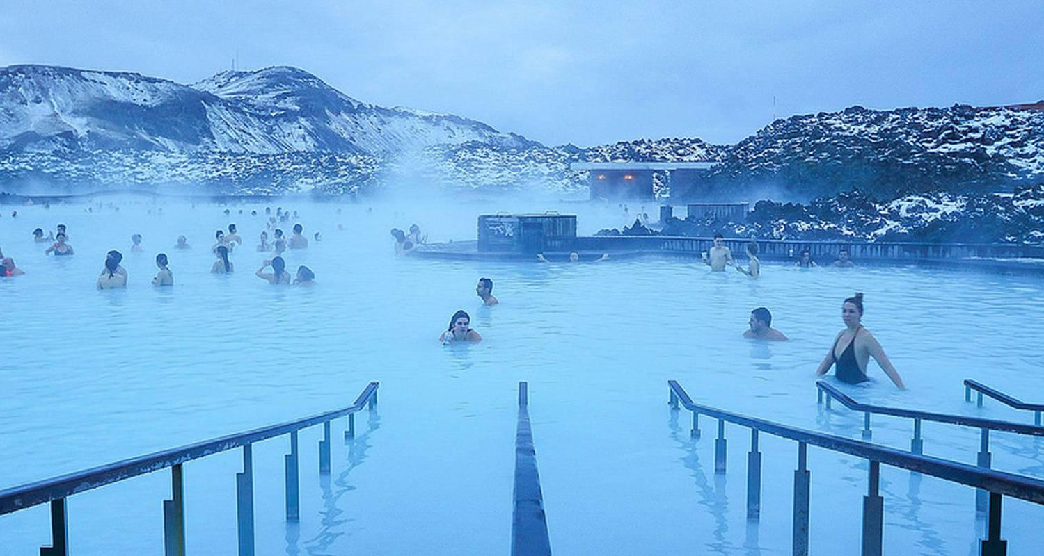

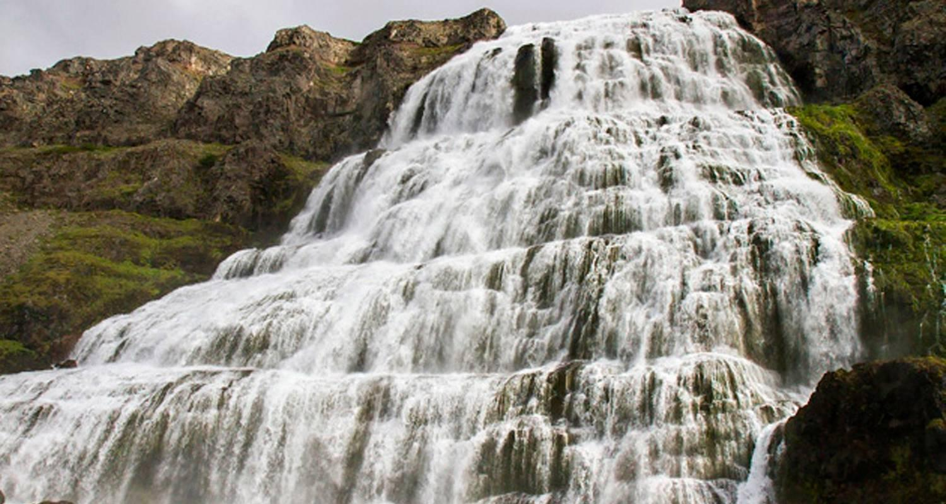

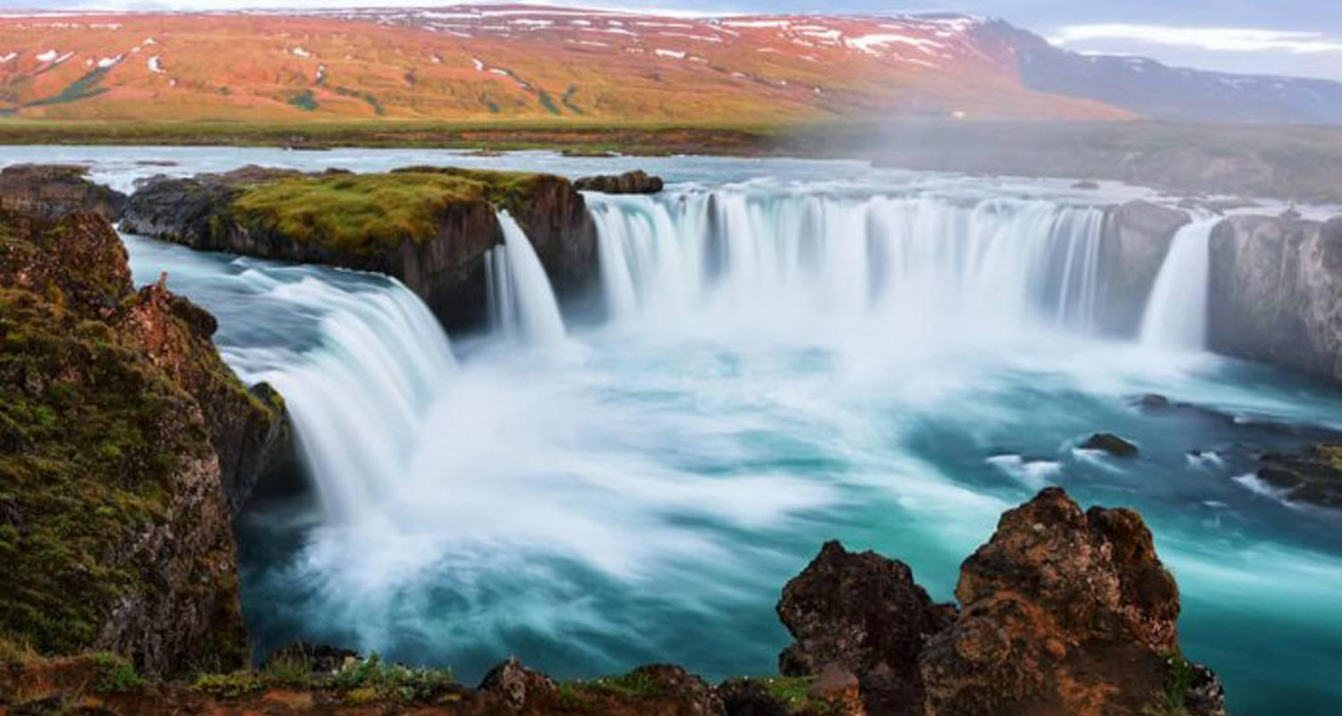

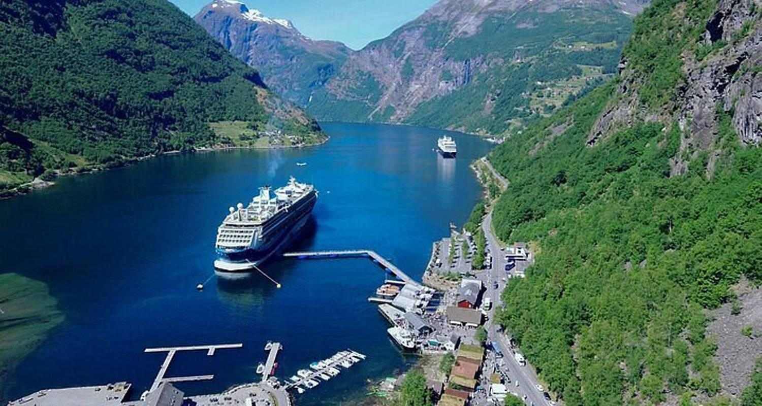

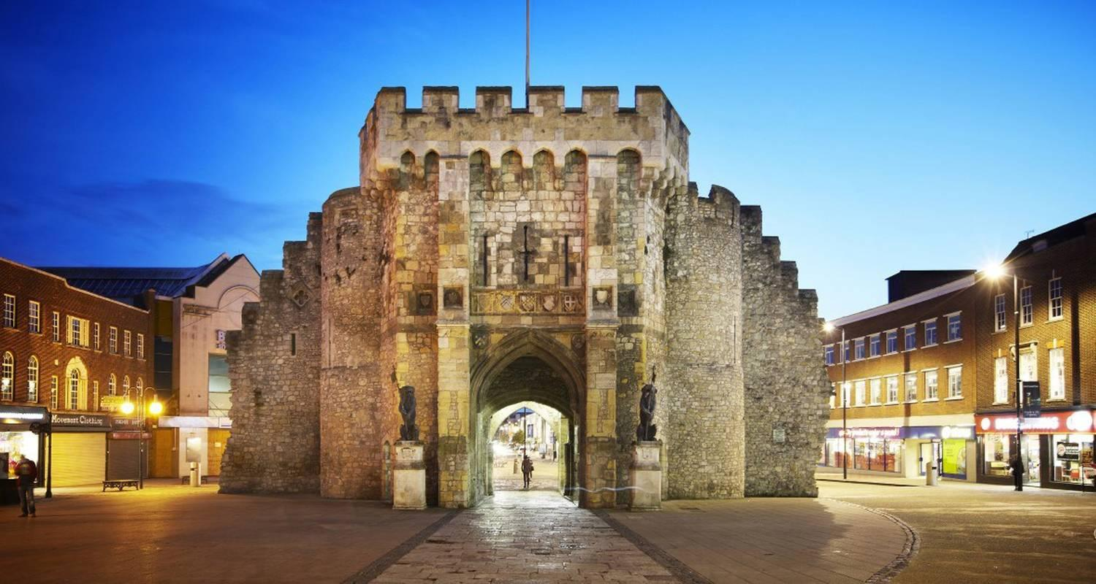

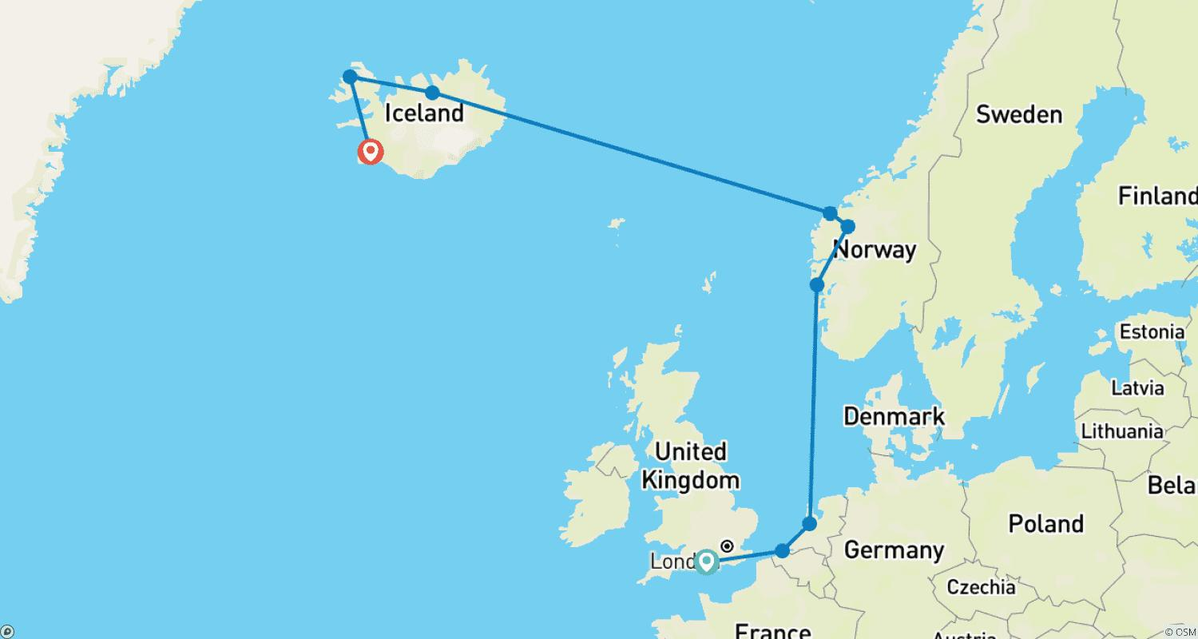

Tour ID: 251032  
Tour Name: Delve Deep: Iceland

Tour destinations: ['Reykjavik', 'Dalvik', 'Akureyri', 'Vatnajokull National Park', 'Jokulsarlon']

Tour destinations images:

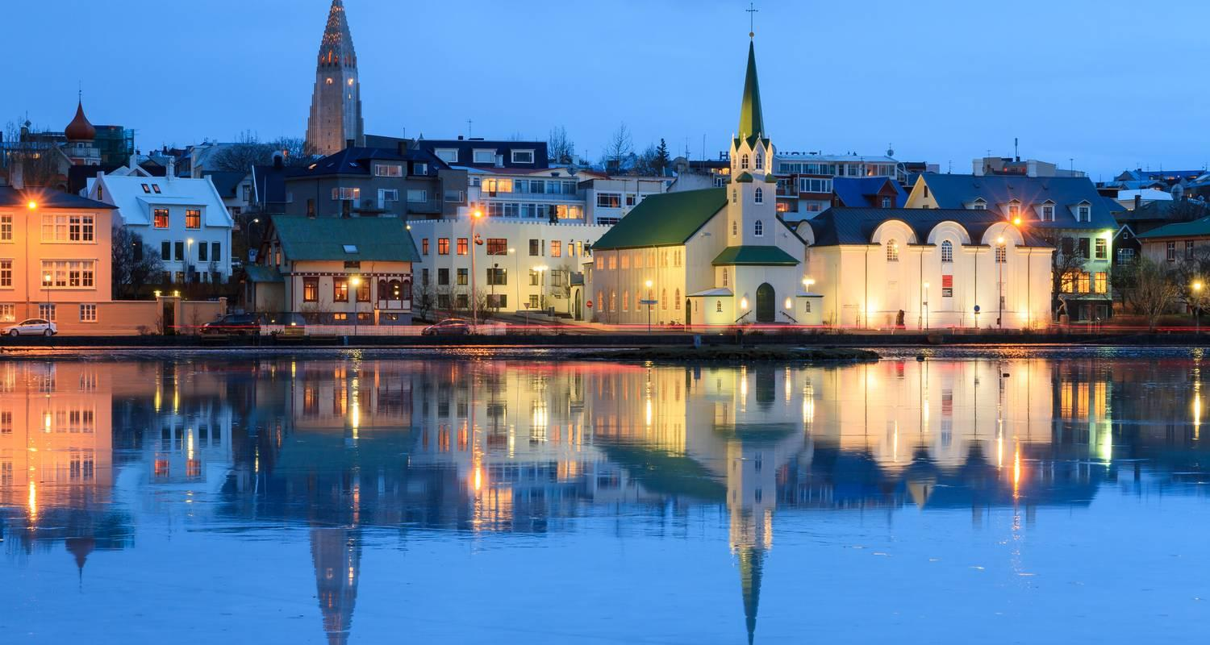

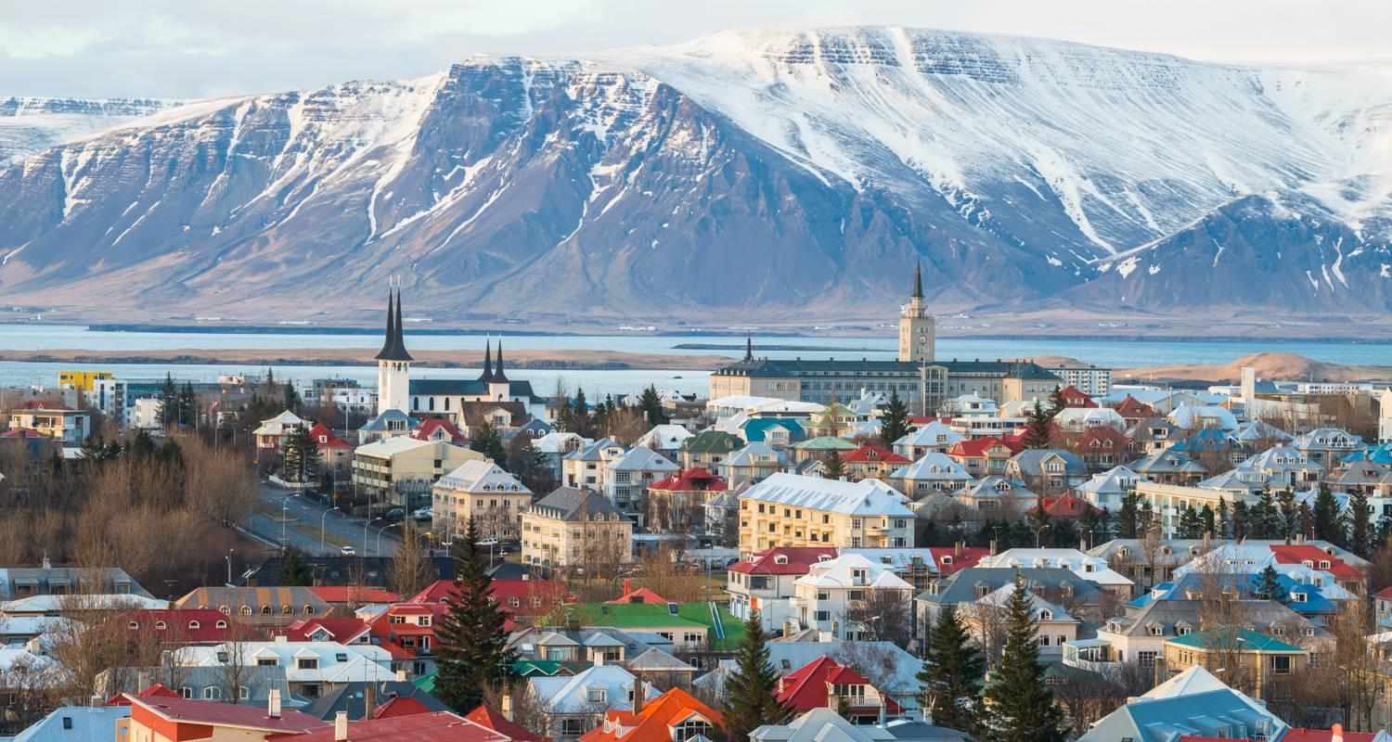

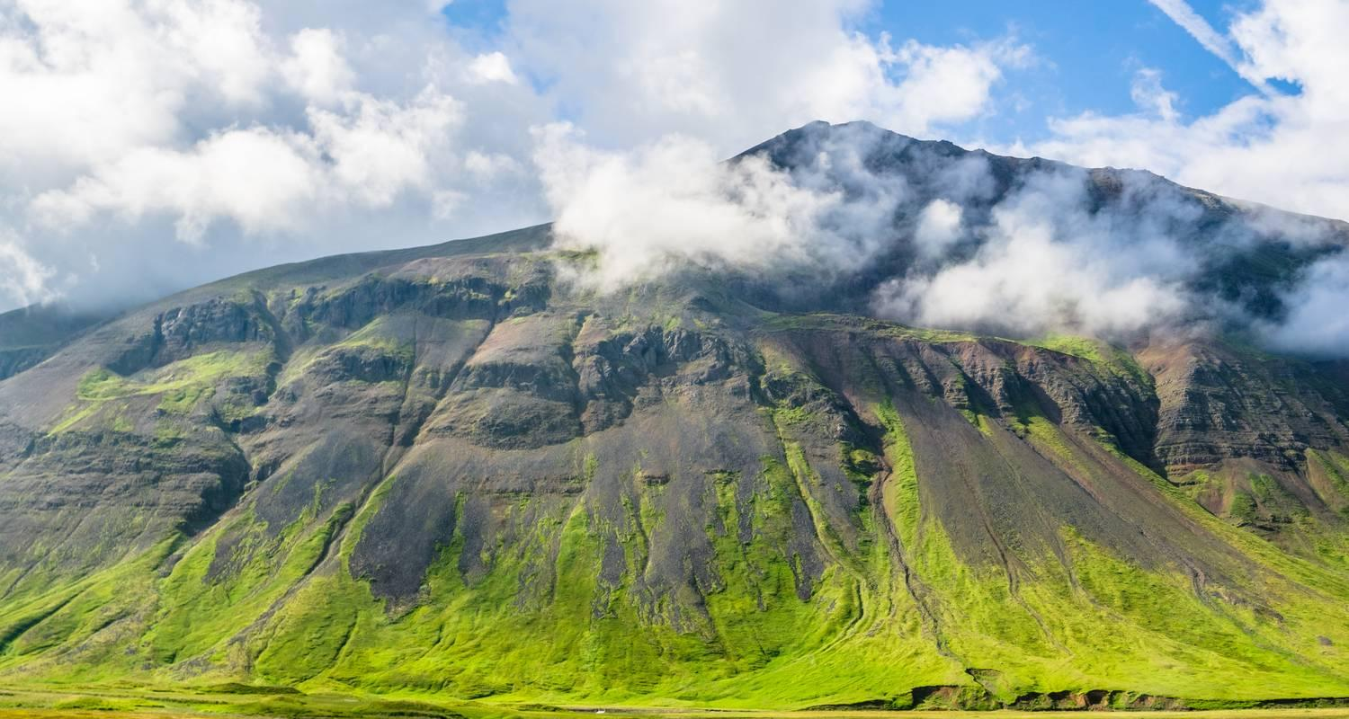

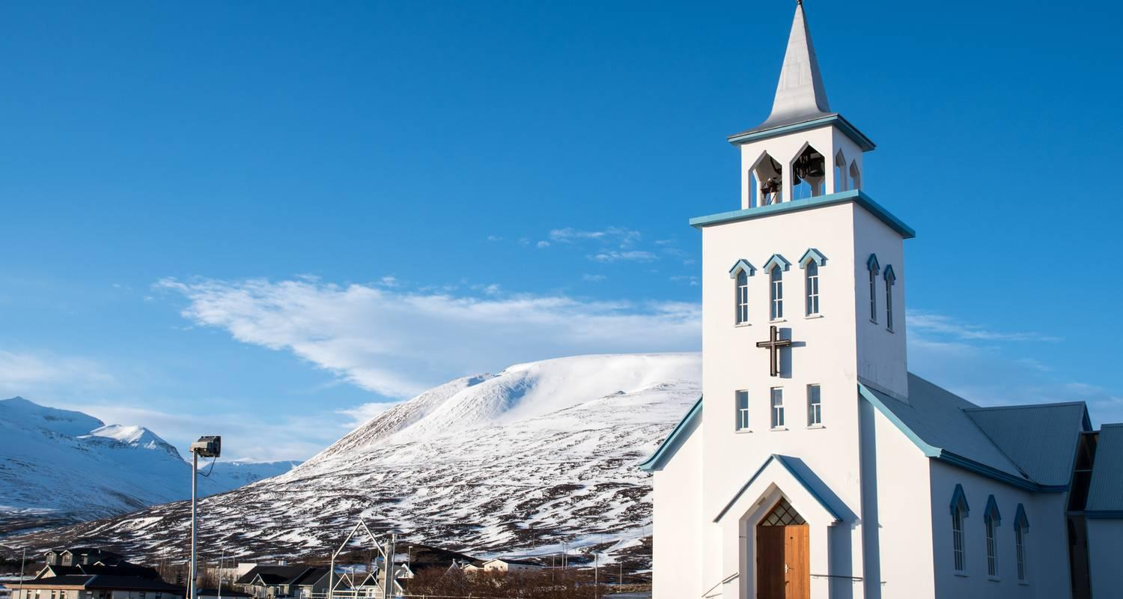

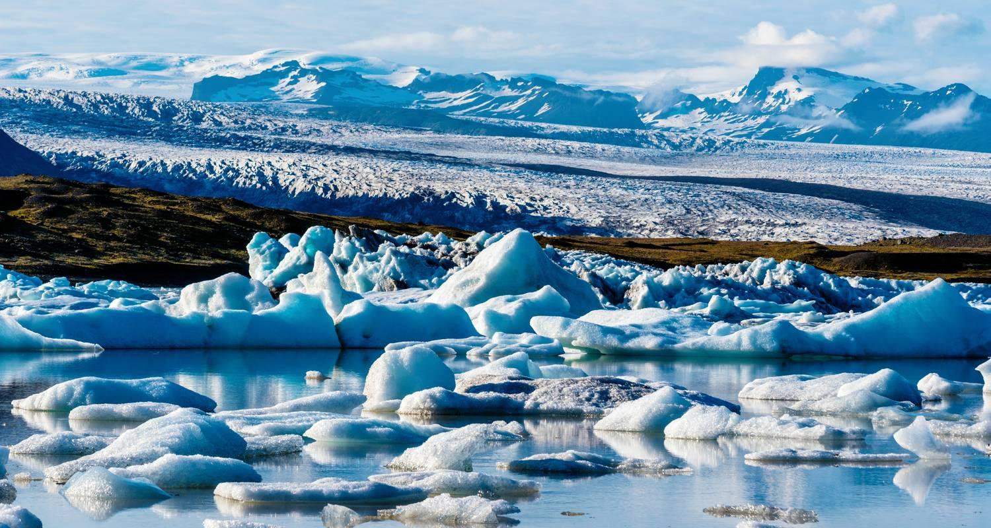

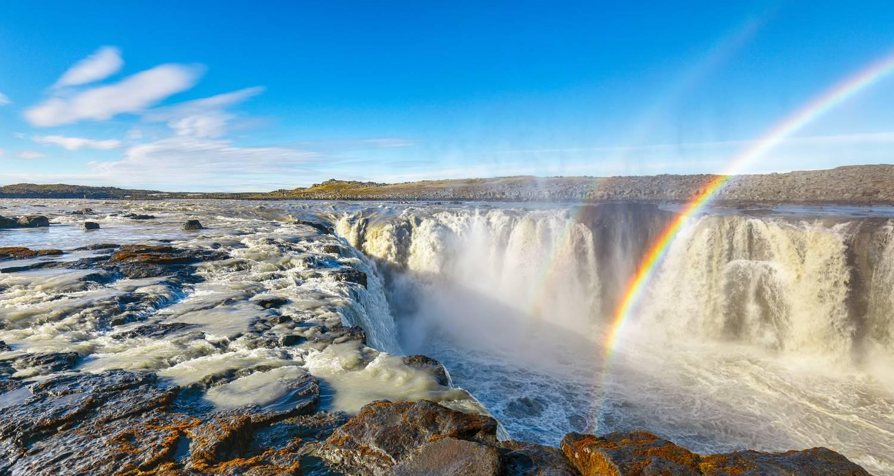

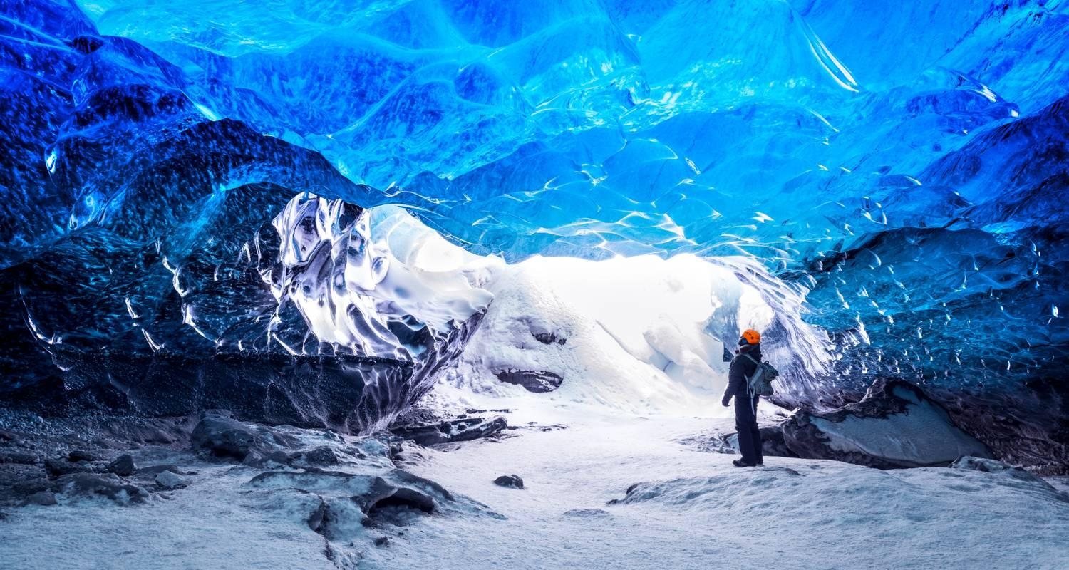

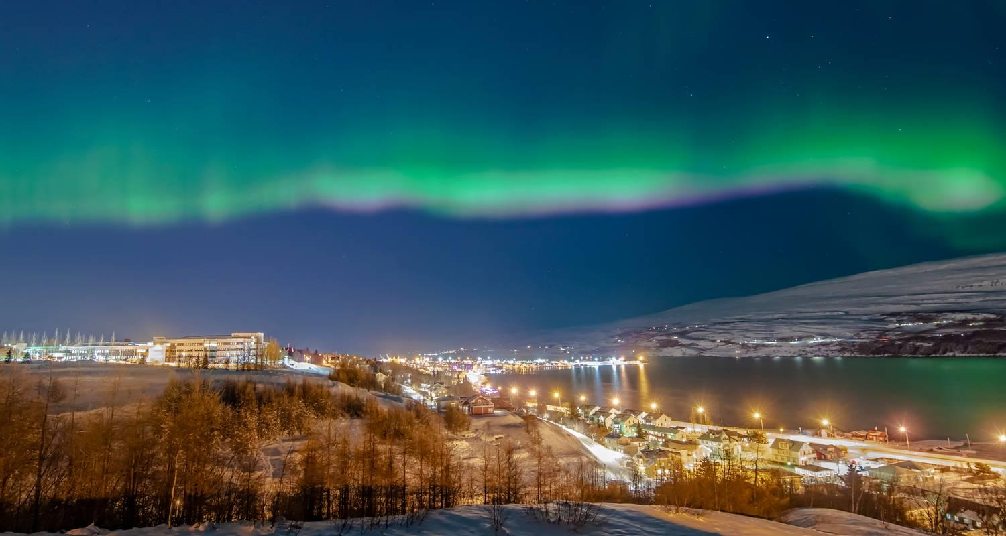

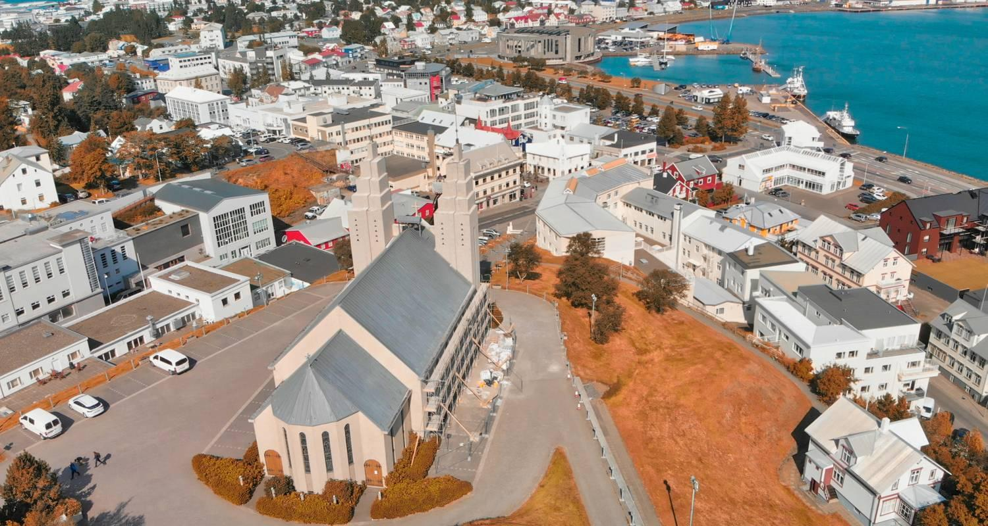

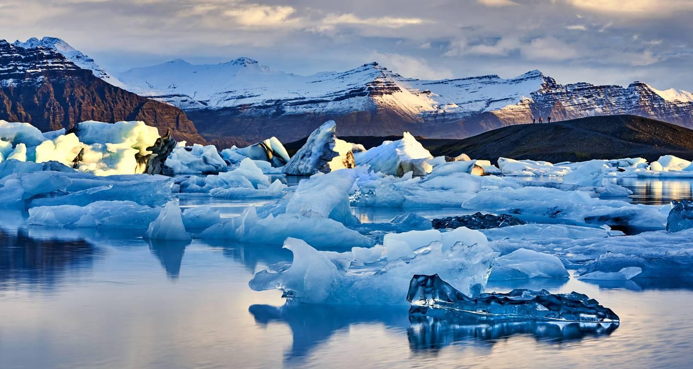

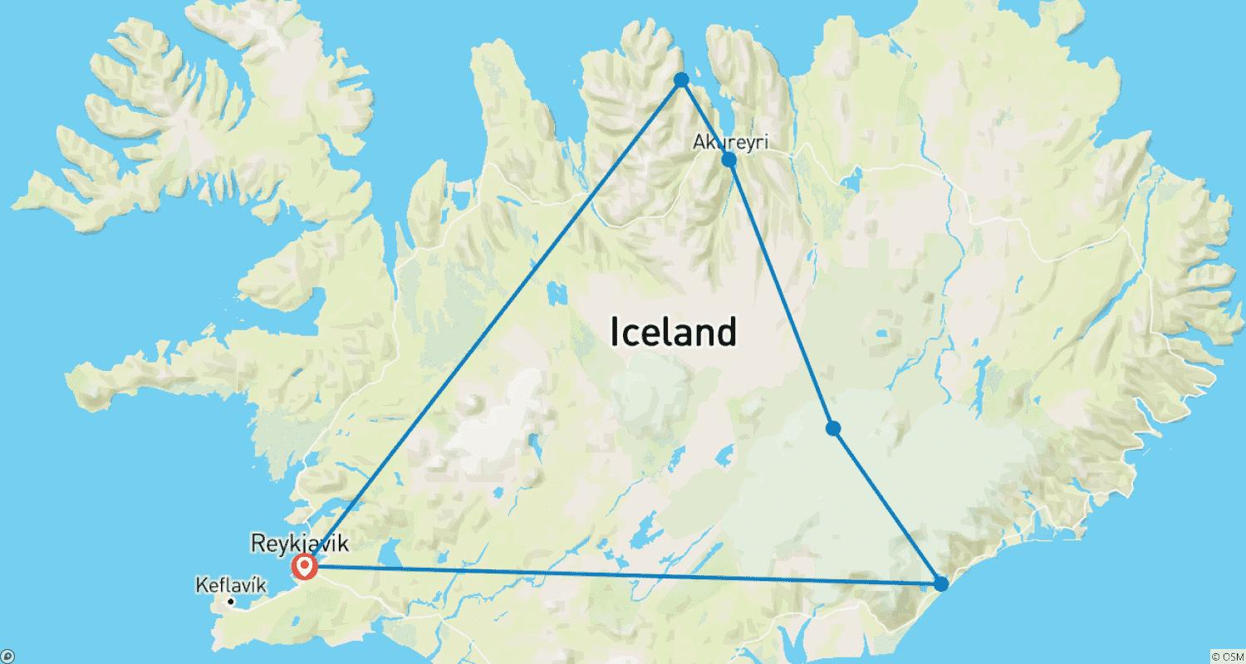

Tour ID: 252843  
Tour Name: Gems of West Greenland: Fjords, Icebergs & Culture, Operated by Quark

Tour destinations: ['Reykjavik', 'Kangerlussuaq', 'Uummannaq', 'Disko Bay', 'Qeqqata']

Tour destinations images:

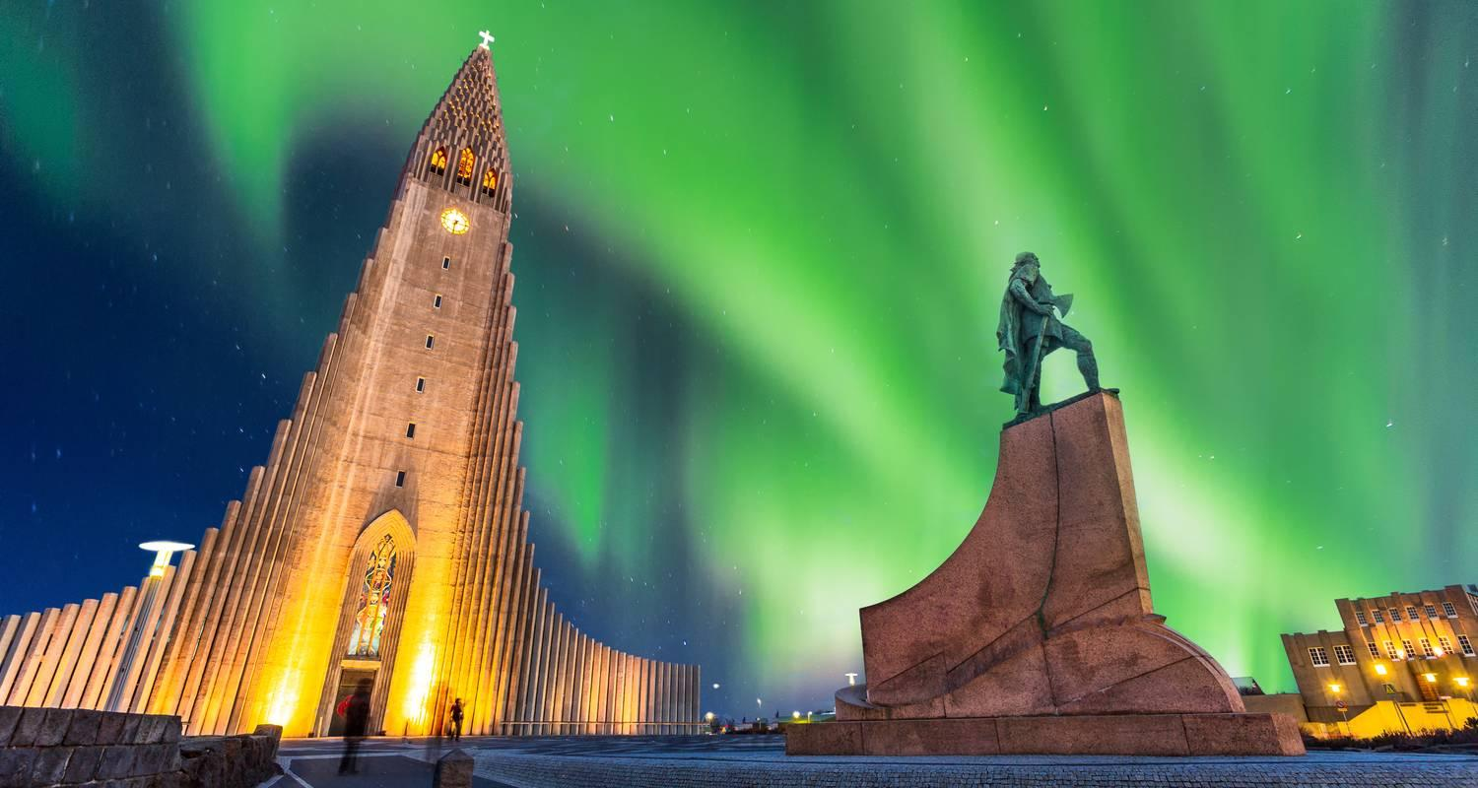

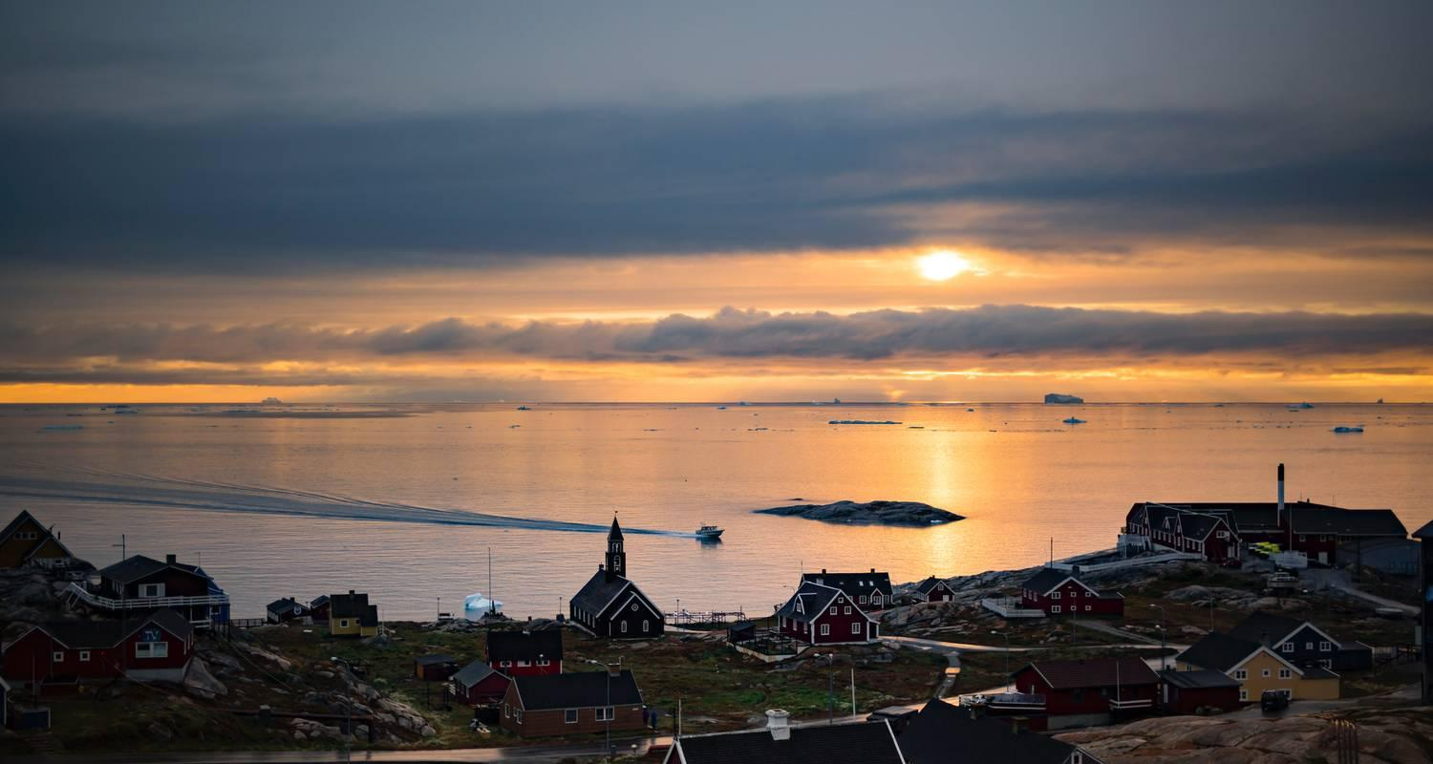

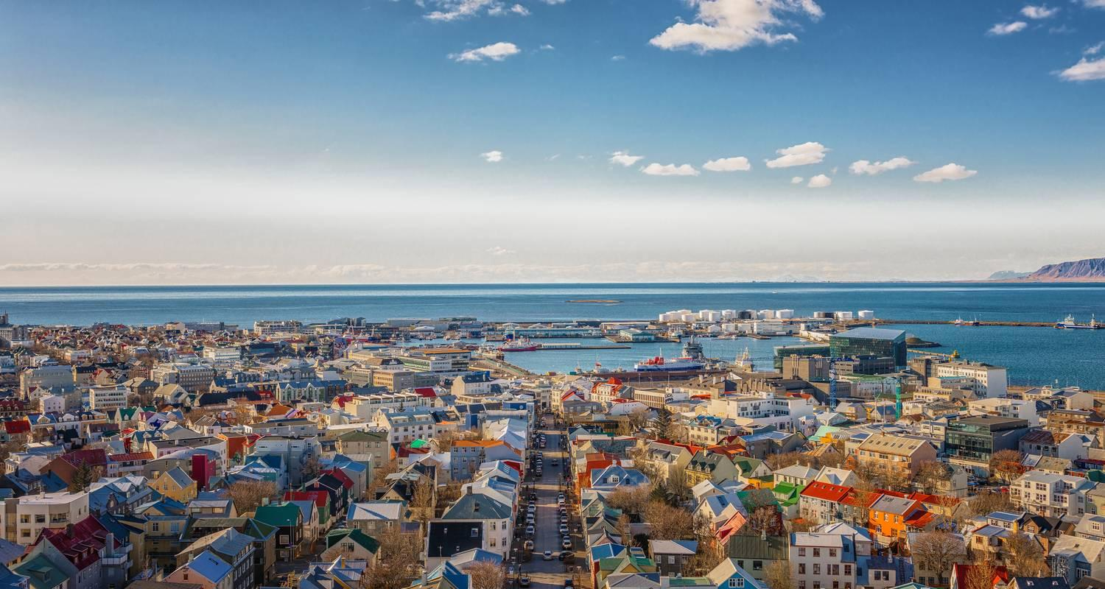

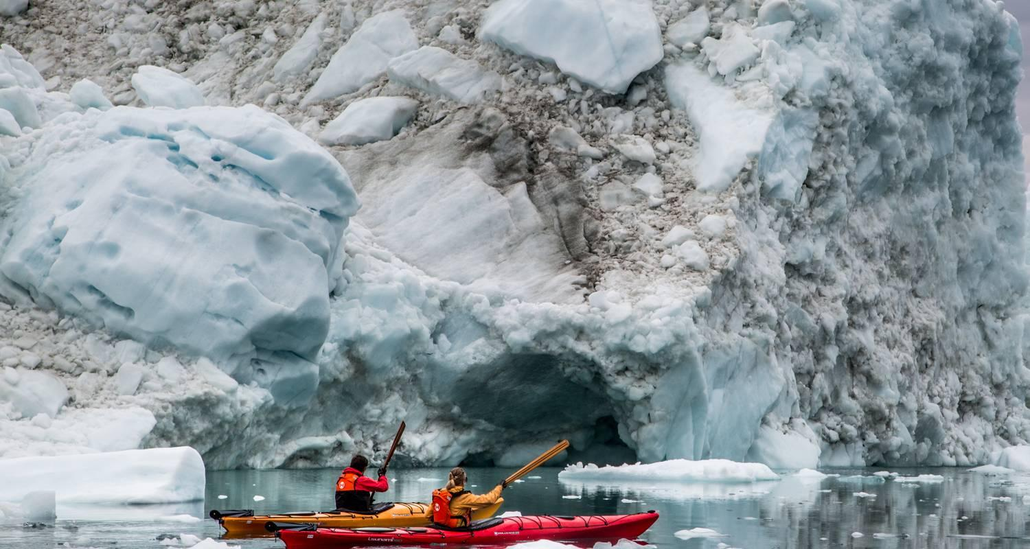

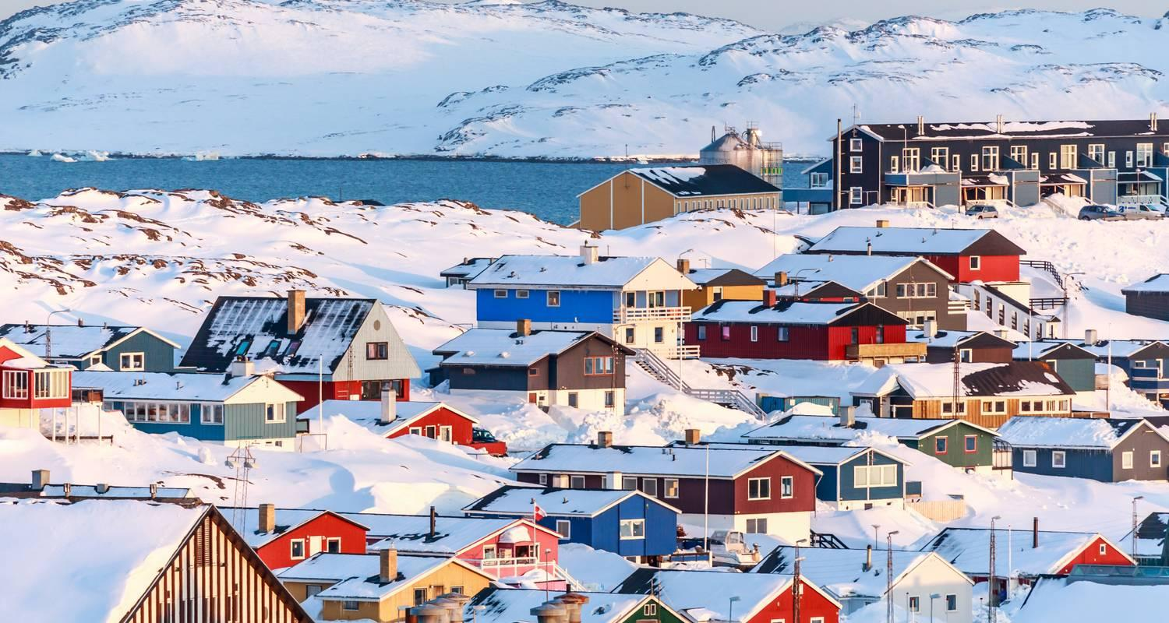

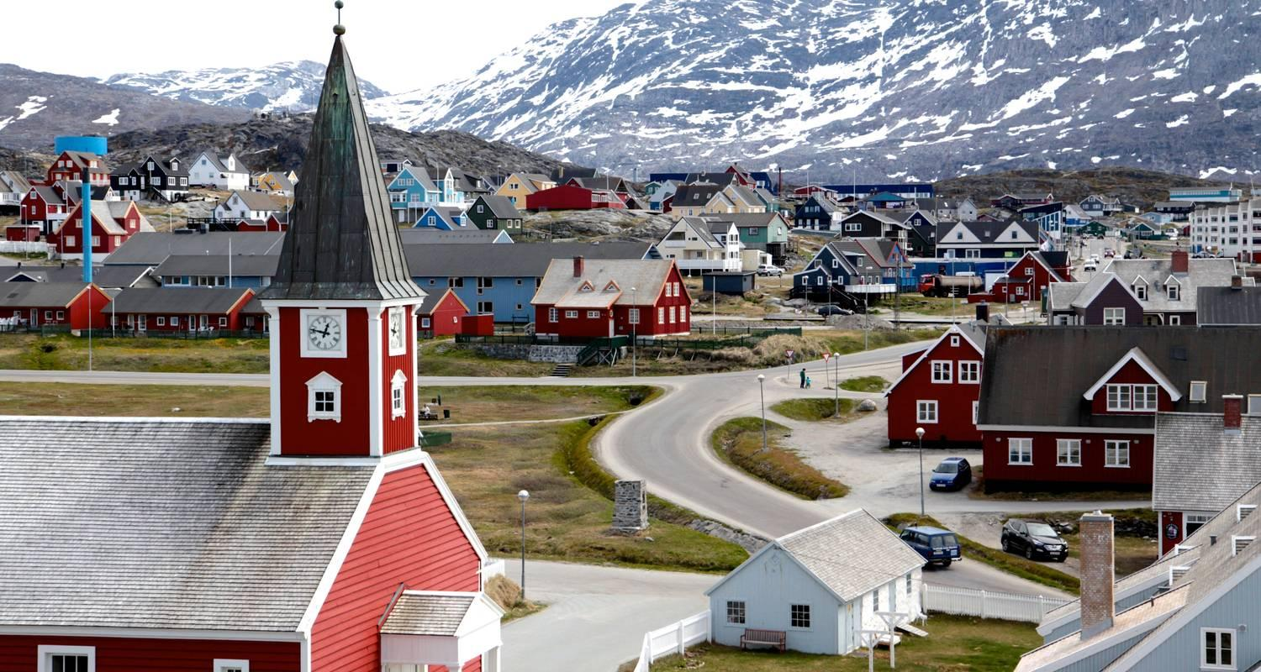

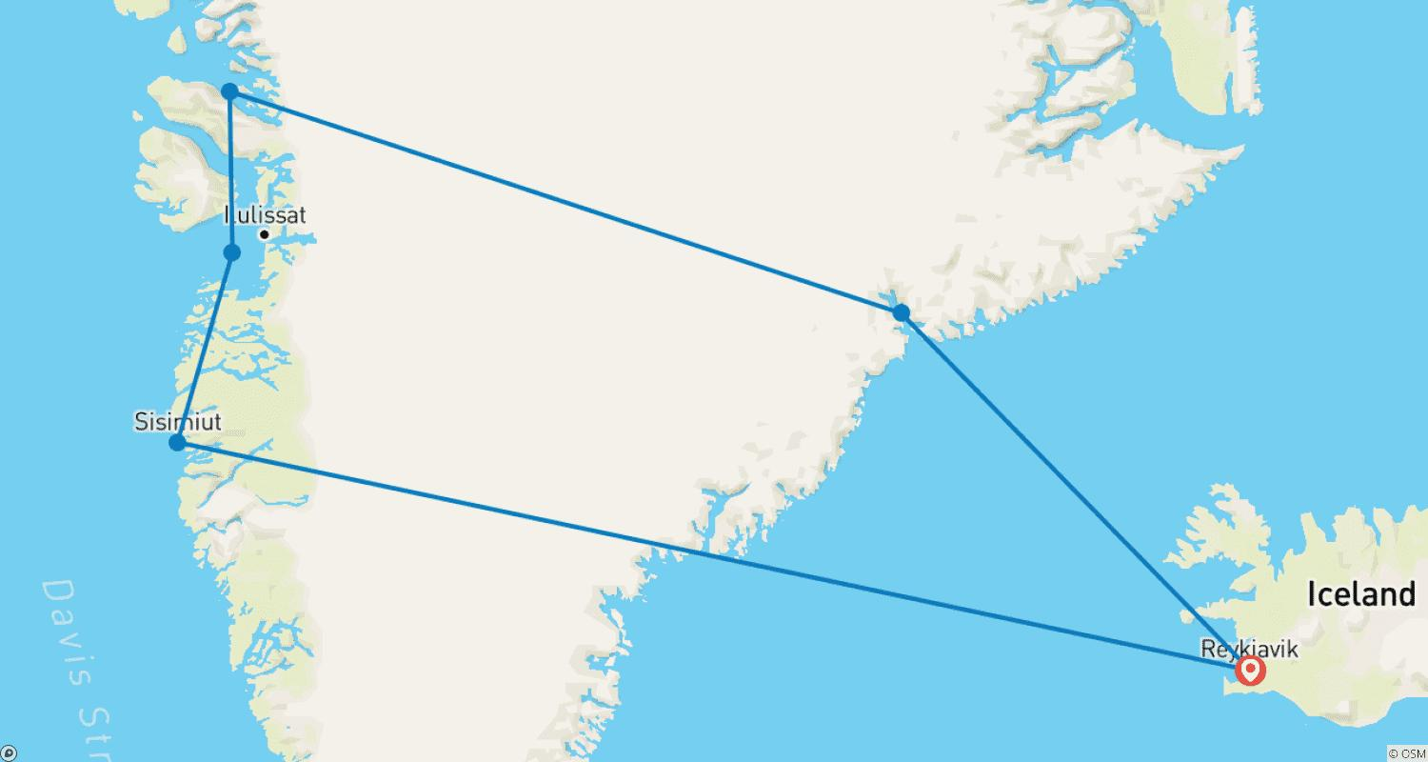

Tour ID: 253408  
Tour Name: 6 Day - Iceland Ring Road Small-Group Tour

Tour destinations: ['Reykjavik', 'Thingvellir National Park', 'Geysir', 'Hvolsvollur', 'Seljaland', 'Skogar', 'Reynisfjara', 'Vik', 'Kirkjubaejarklaustur', 'Jokulsarlon', 'Hofn', 'Djupivogur', 'Egilsstadir', 'Dettifoss', 'Mount Namaskard', 'Myvatn', 'Dimmuborgir', 'Skutustadagigar', 'Godafoss', 'Akureyri', 'Blonduos', 'Hvitserkur', 'Laugarbakki', 'Grábrók Volcano', 'Hraunfossar', 'Reykholt', 'Borgarnes']

Tour destinations images:

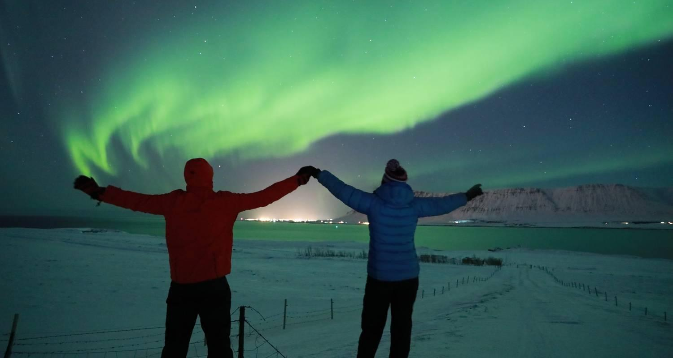

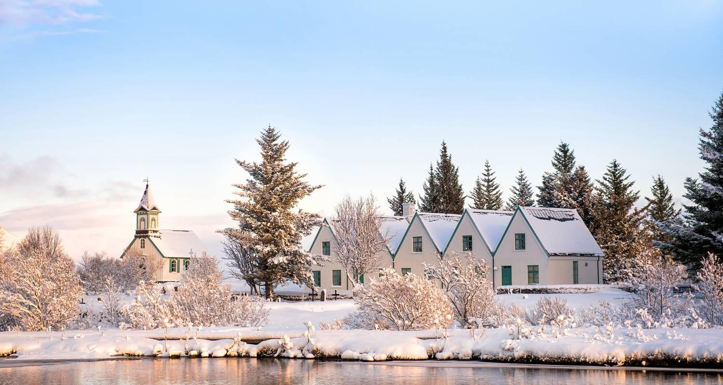

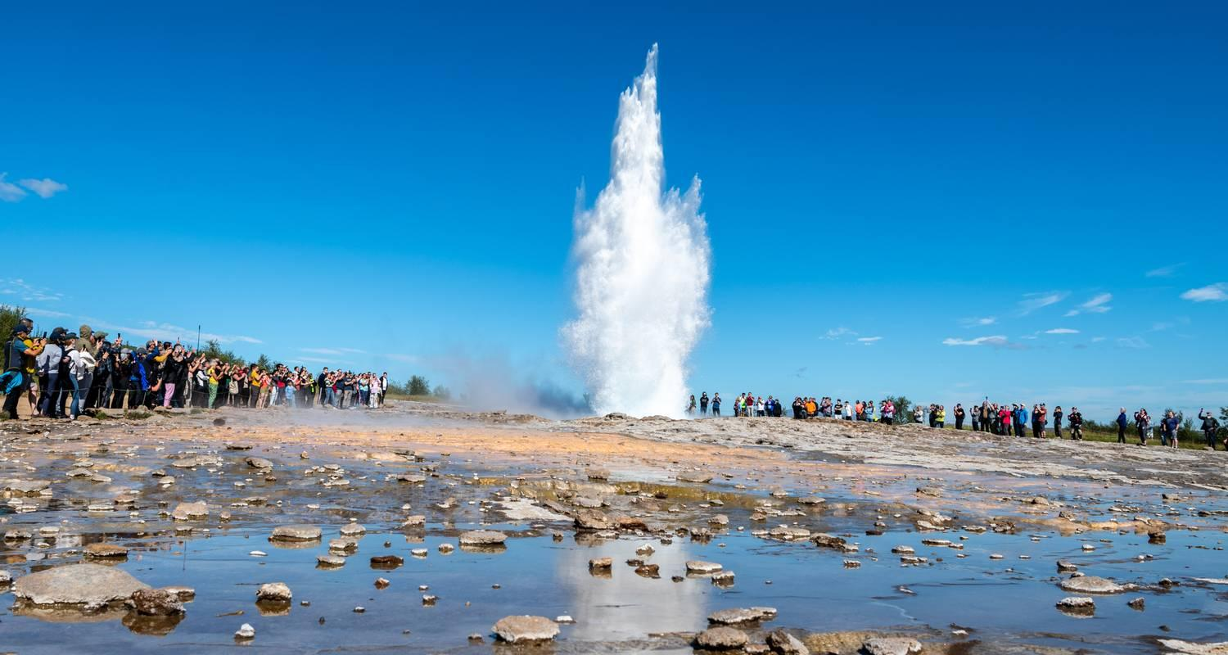

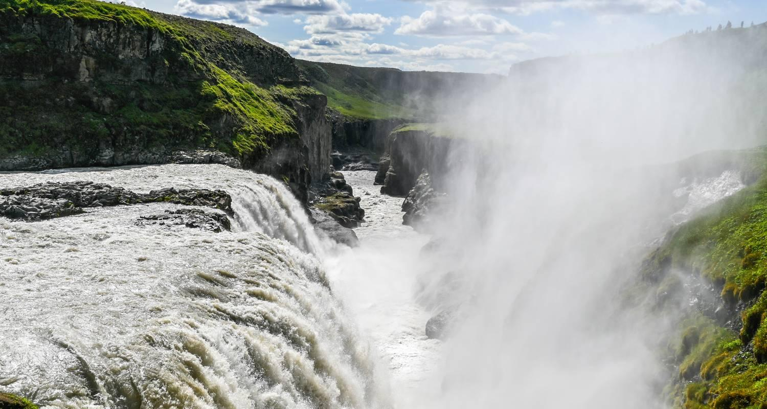

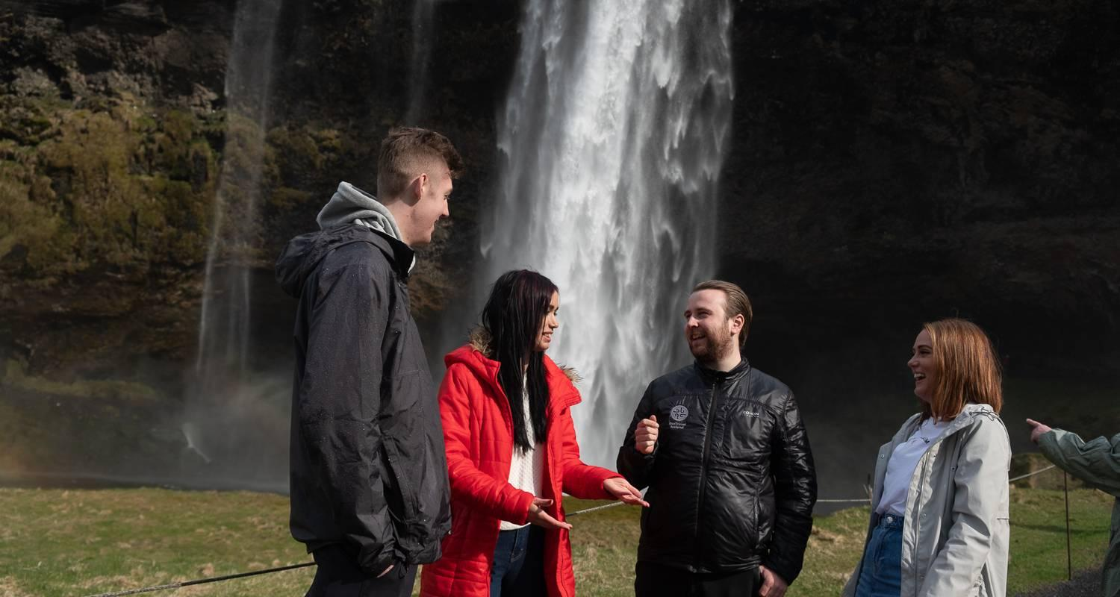

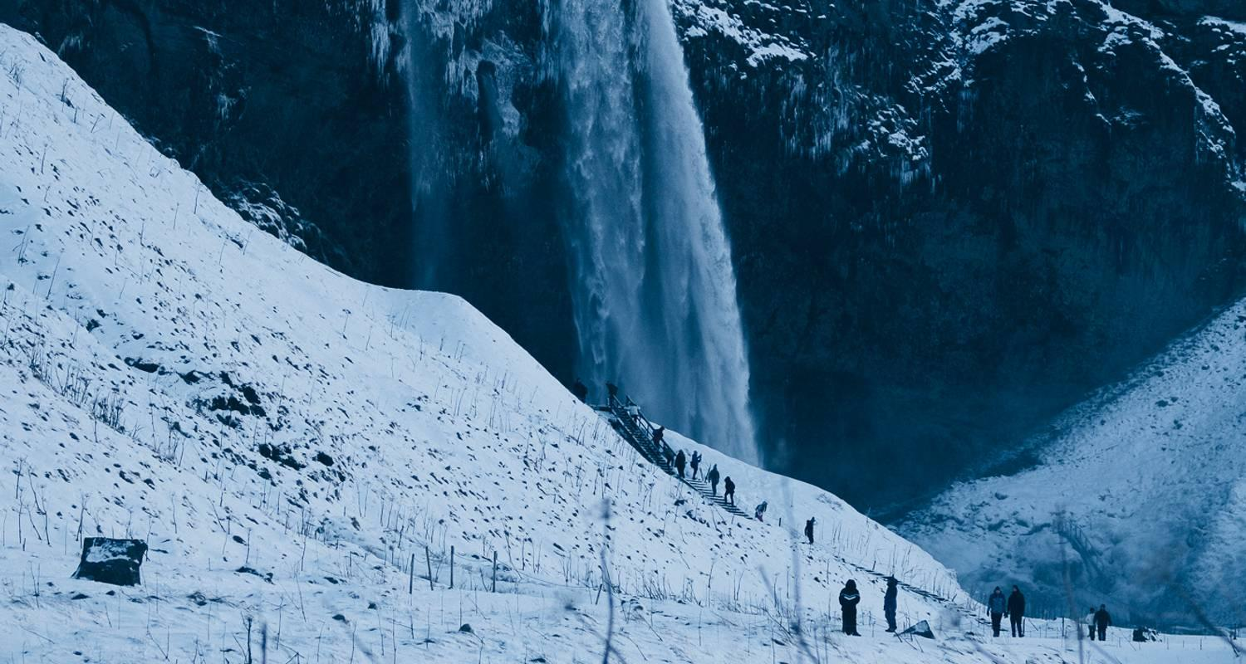

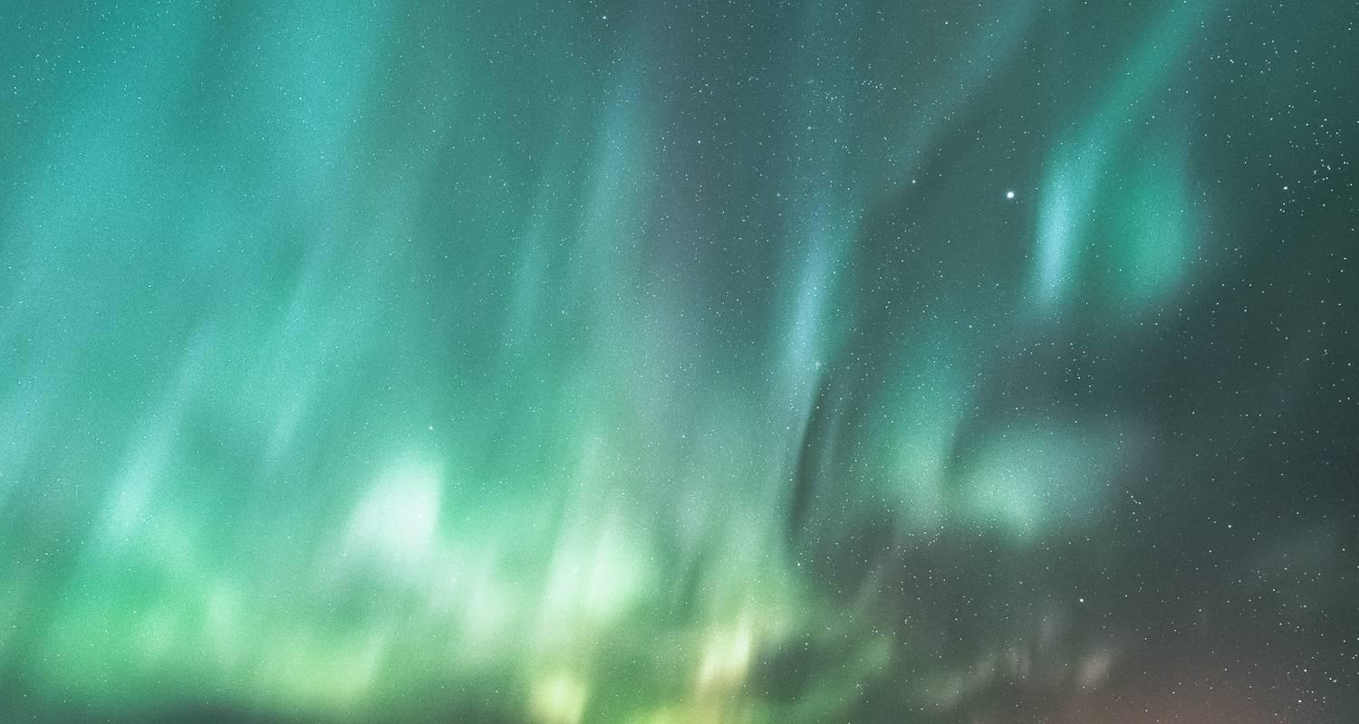

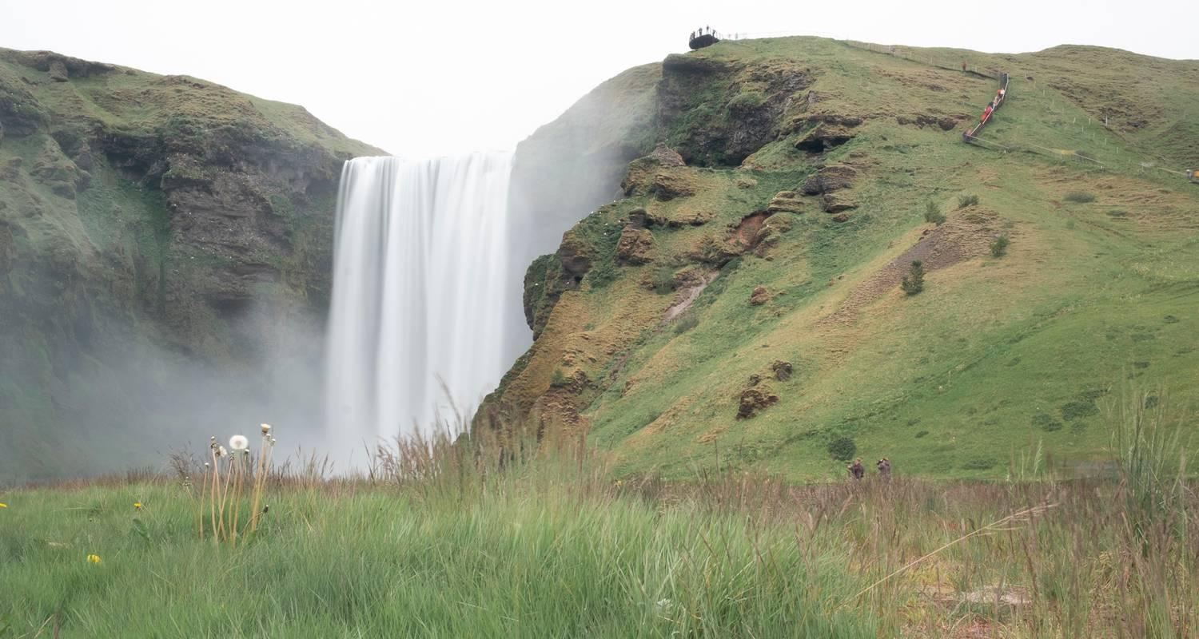

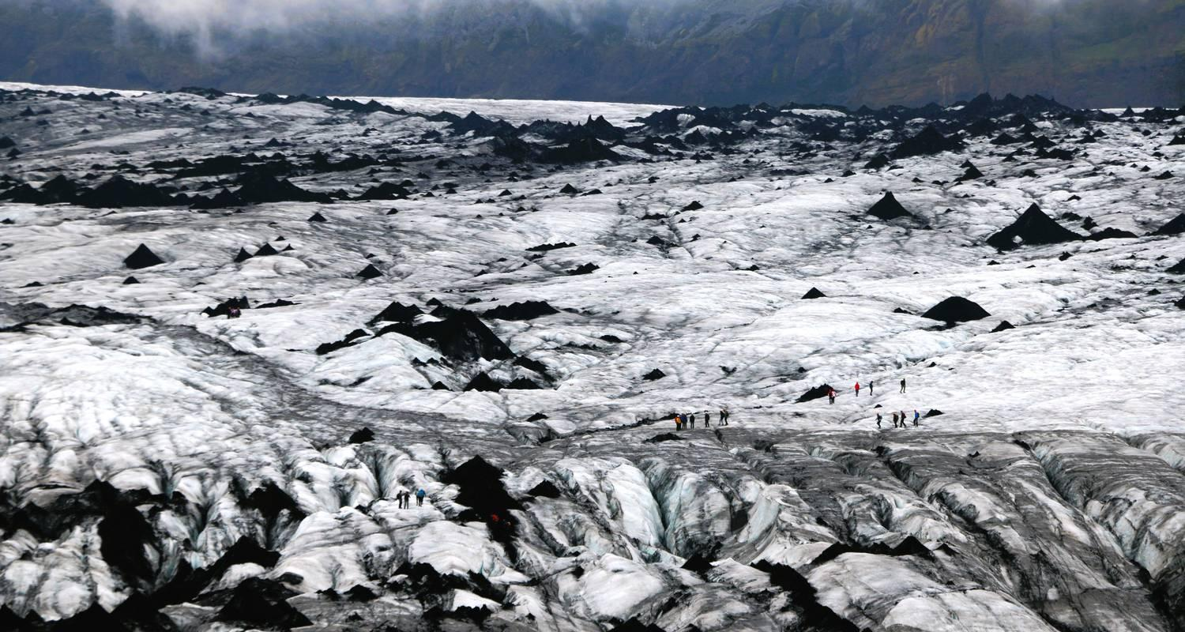

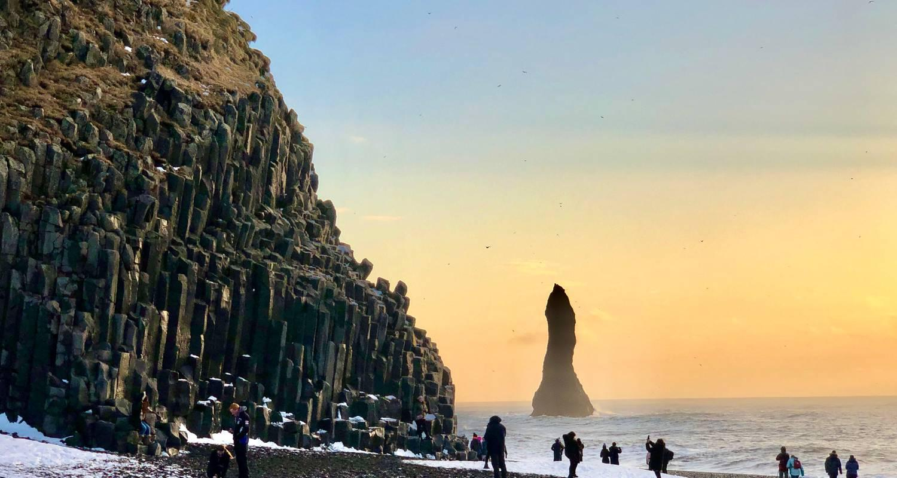

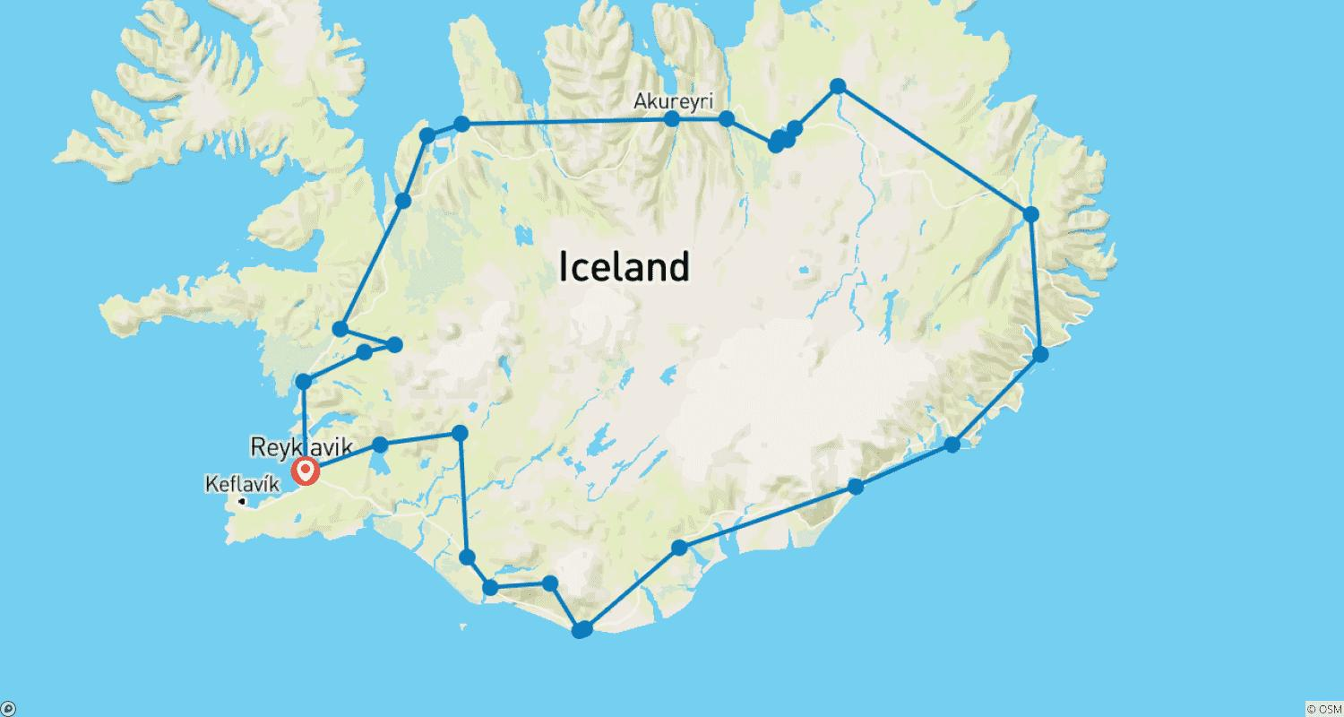

Tour ID: 254261  
Tour Name: Customized Private Iceland Tour with Golden Circle

Tour destinations: ['Reykjavik']

Tour destinations images:

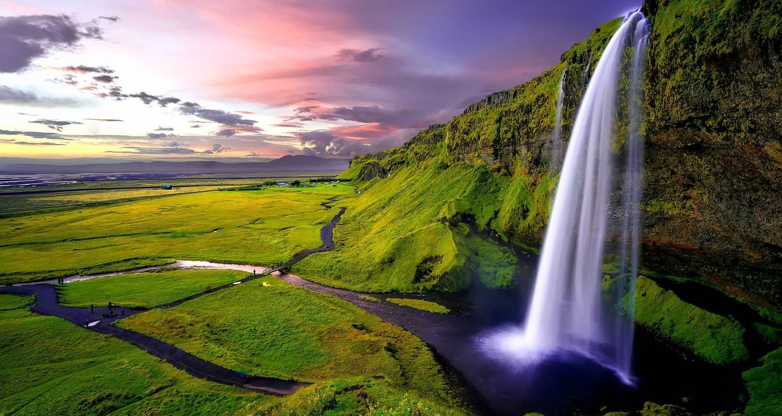

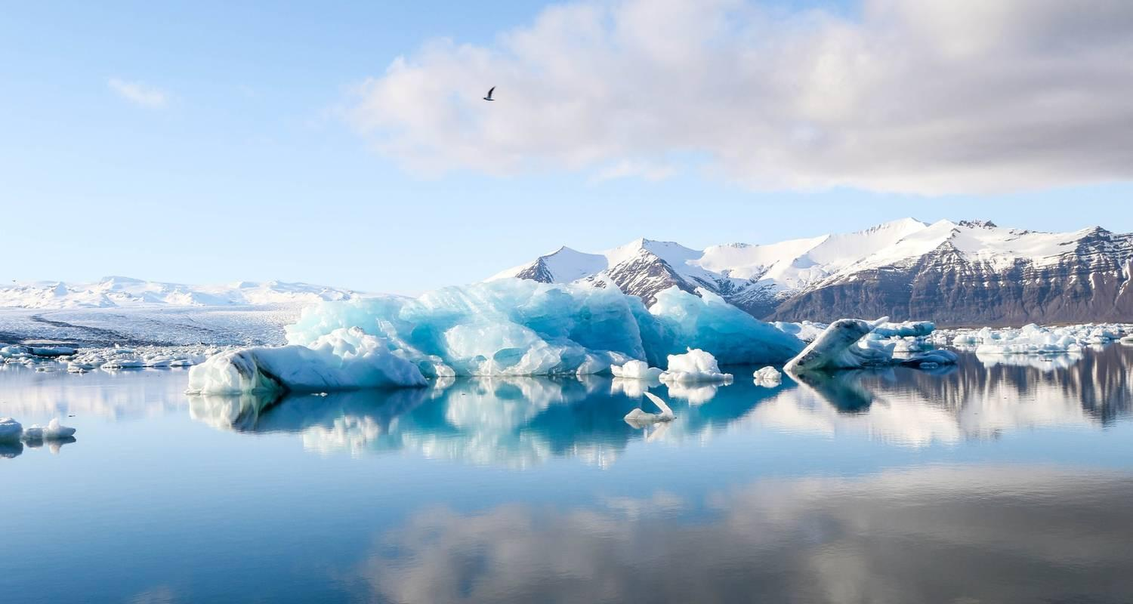

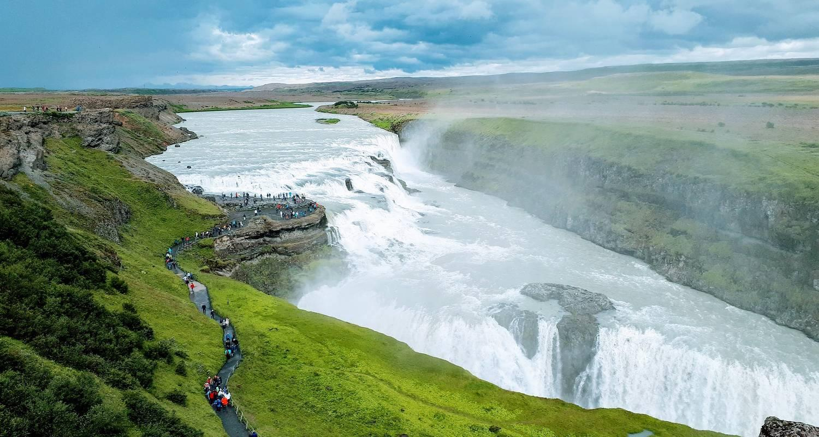

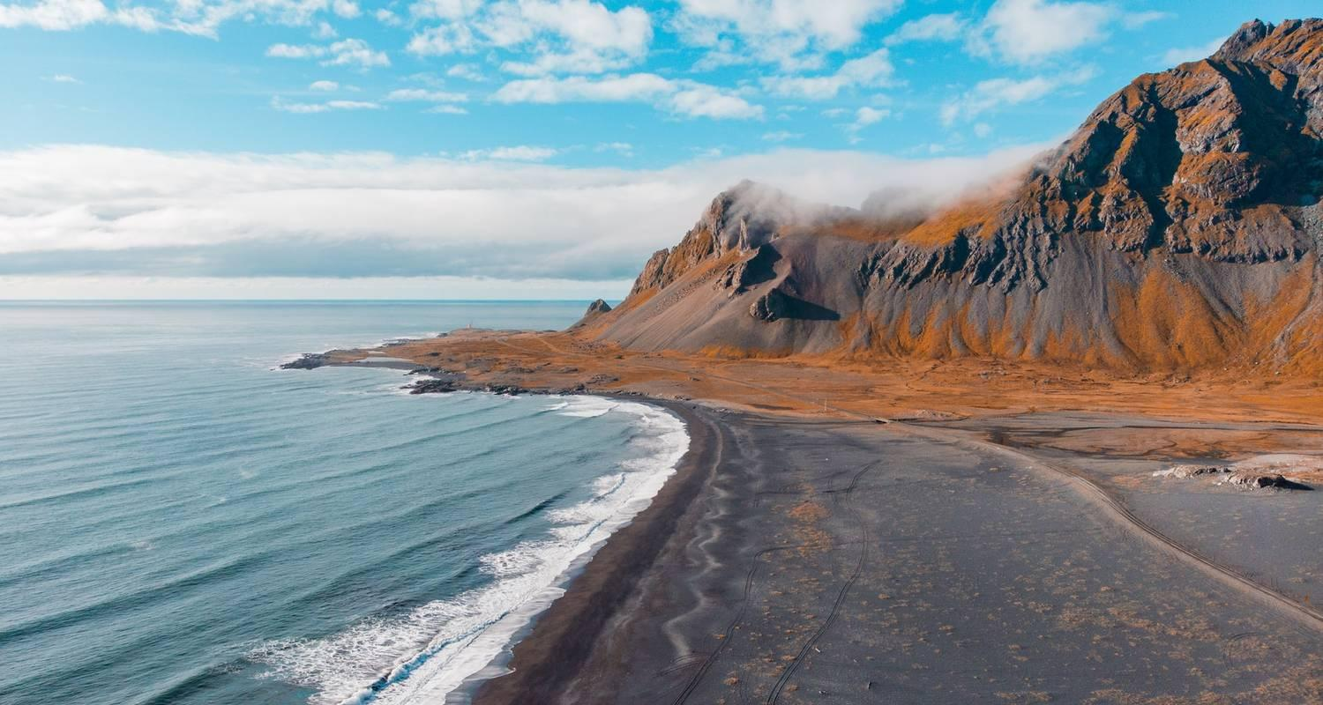

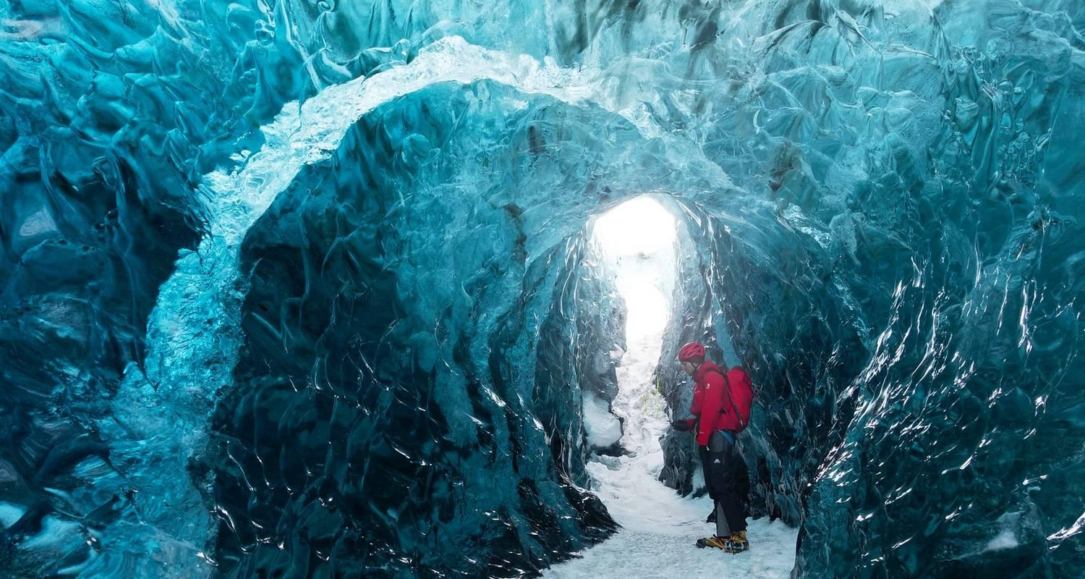

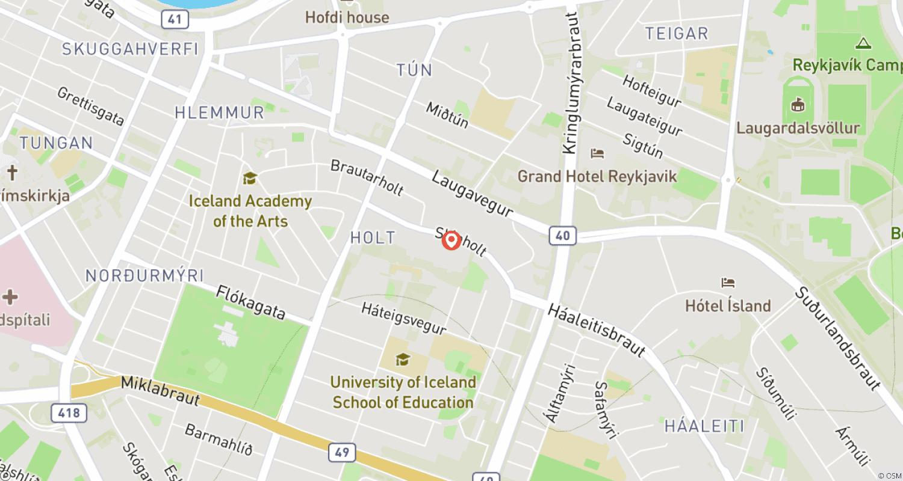

Tour ID: 254262  
Tour Name: Tailor-Made Private Trip to Iceland

Tour destinations: ['Reykjavik', 'Vik', 'Vatnajokull National Park', 'Skaftafell', 'Myvatn', 'Akureyri', 'Reykholt']

Tour destinations images:

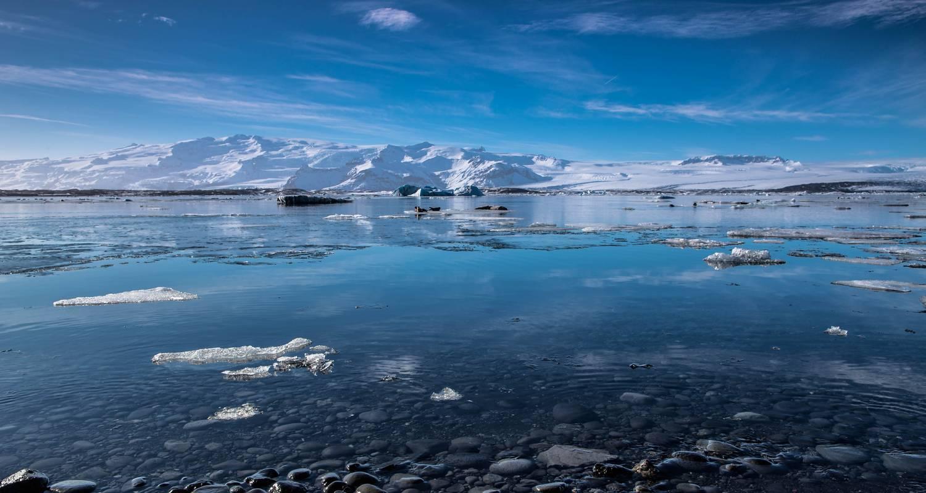



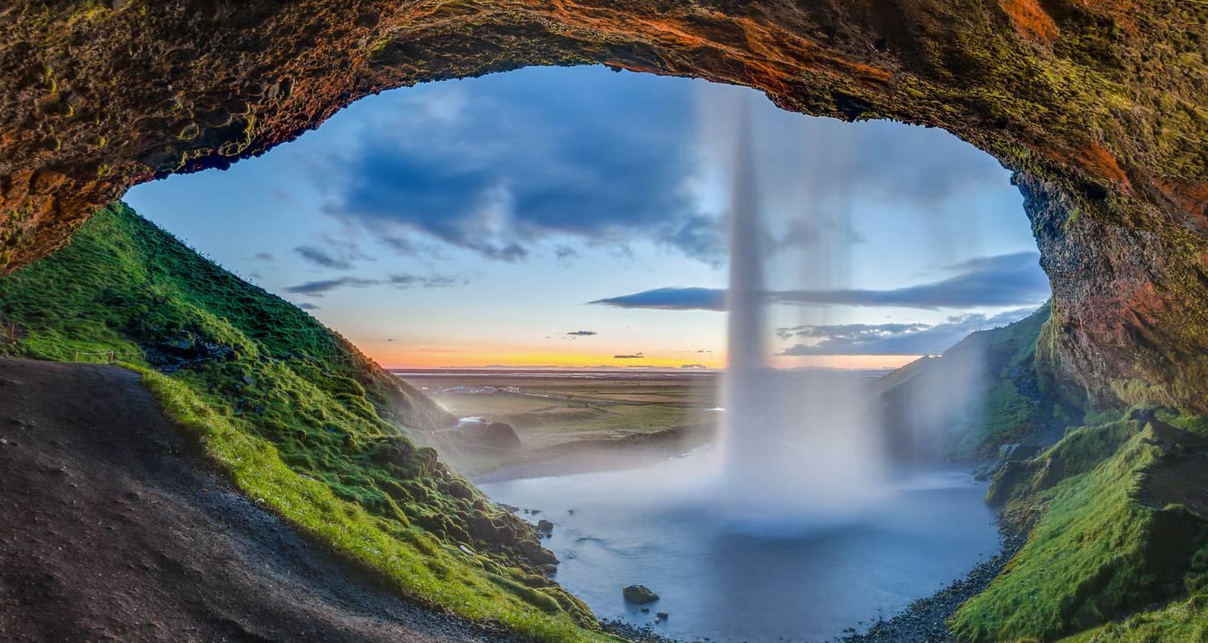

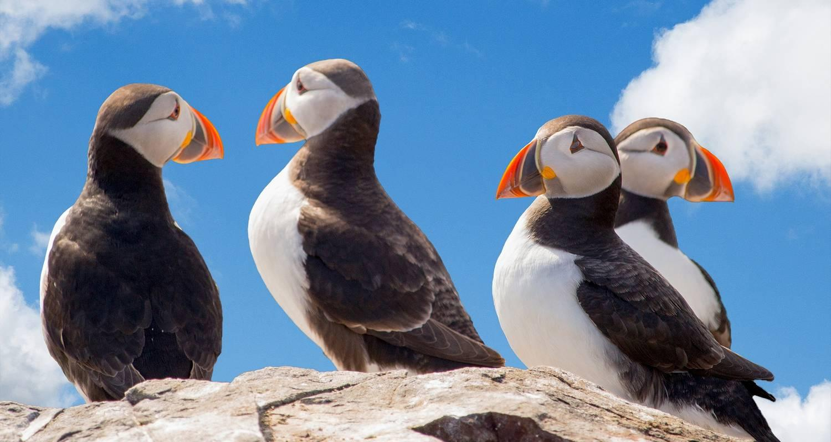



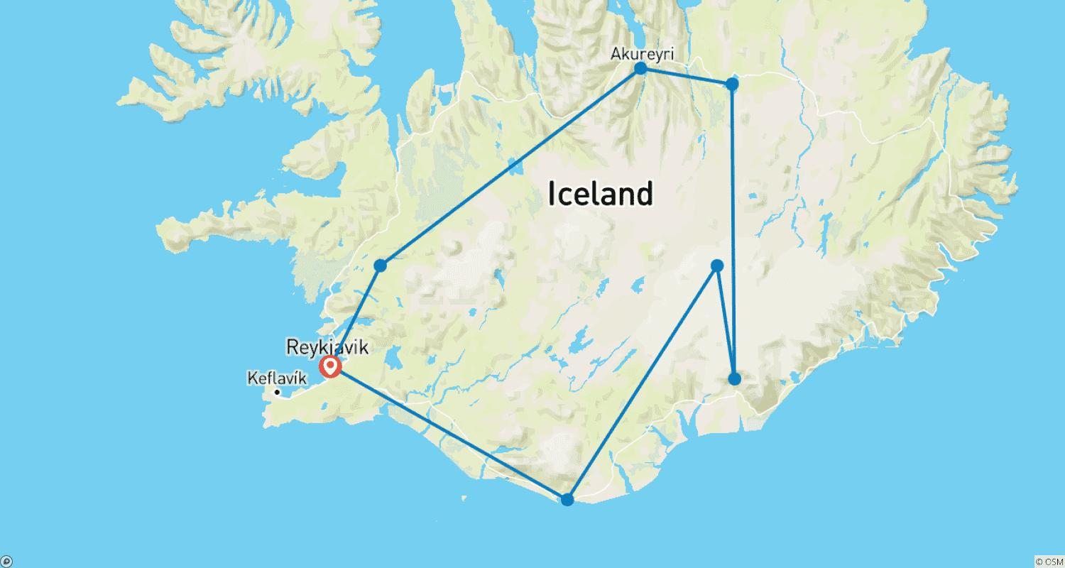

Tour ID: 254438  
Tour Name: 3 Day Winter Package with Golden Circle, South Coast & Aurora

Tour destinations: ['Reykjavik', 'Kerid Volcano', 'Gullfoss', 'Geysir', 'Thingvellir National Park', 'Skogafoss', 'Vik', 'Reynisfjara', 'Reynisdrangar Cliffs', 'Solheimajokull', 'Seljaland']

Tour destinations images:

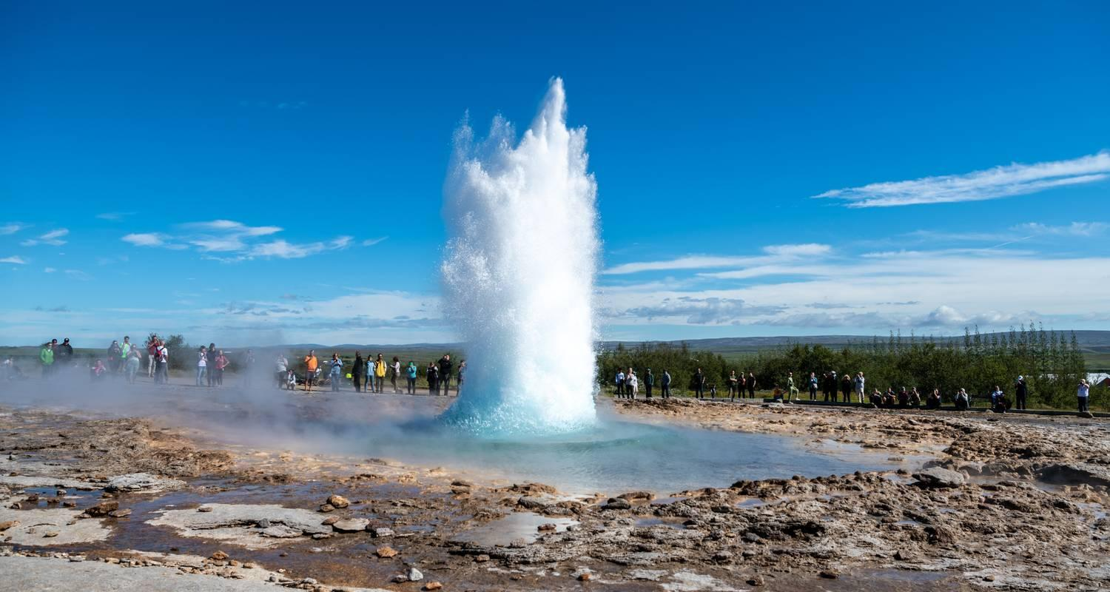

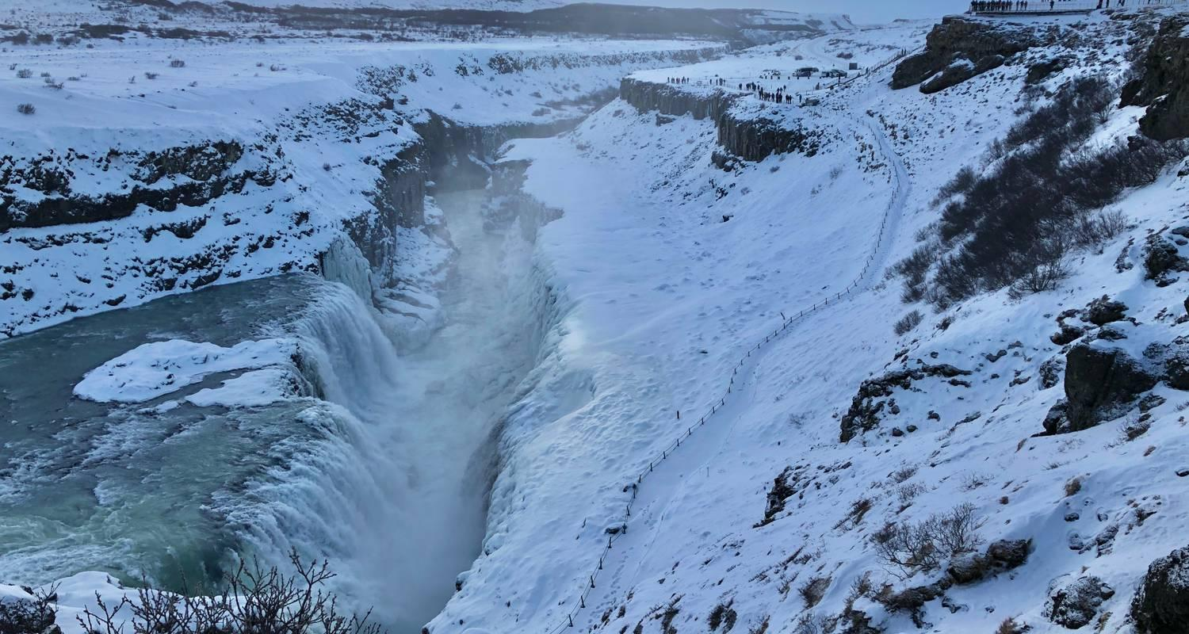



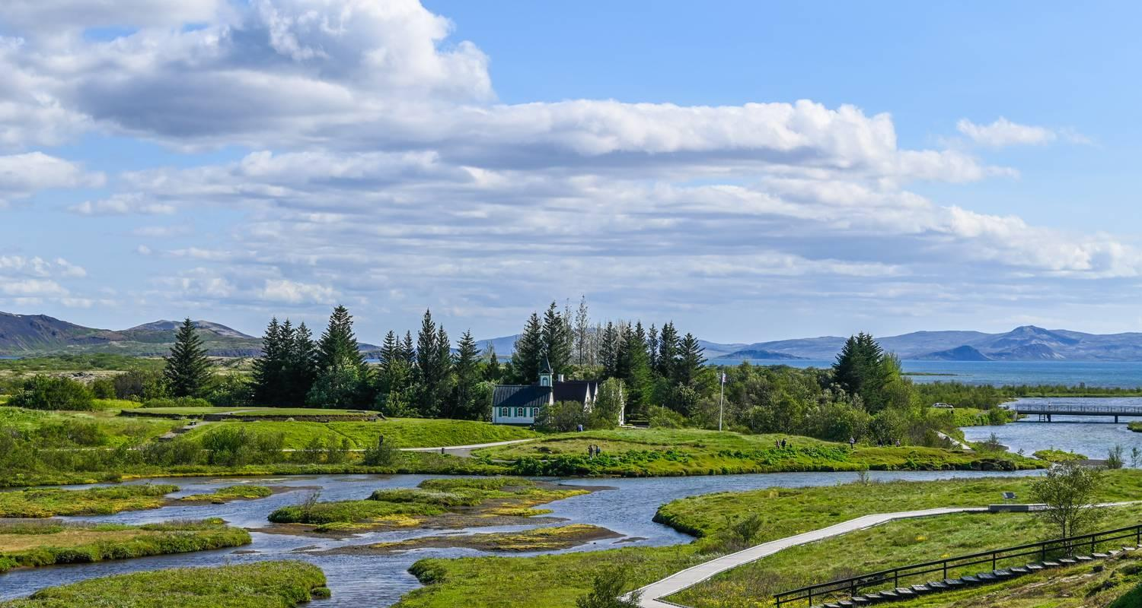

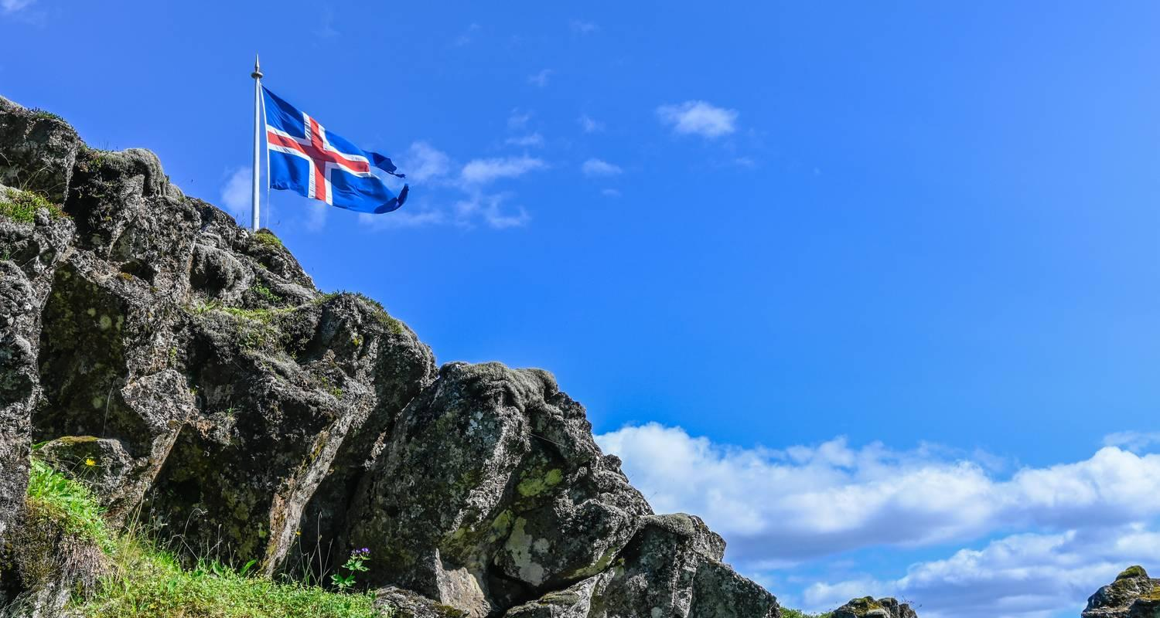

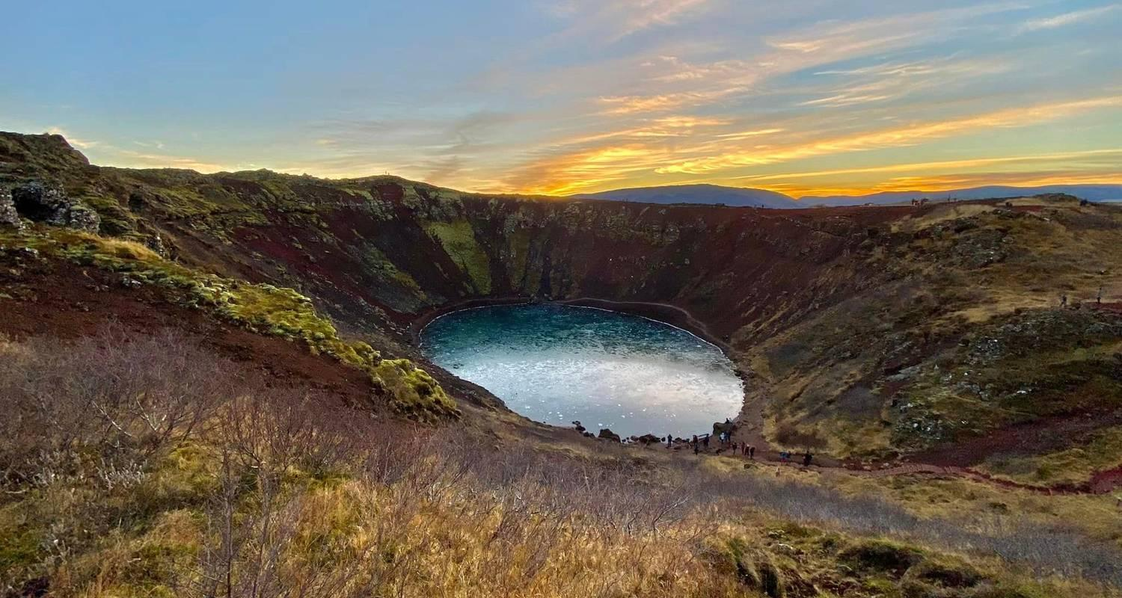

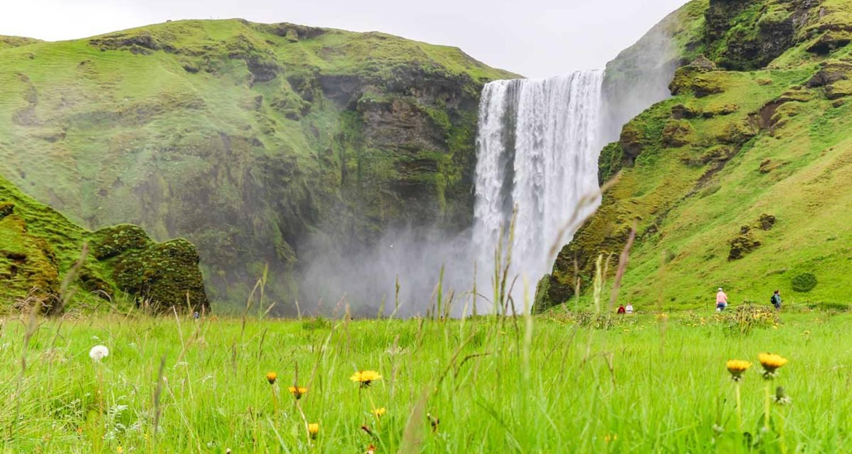

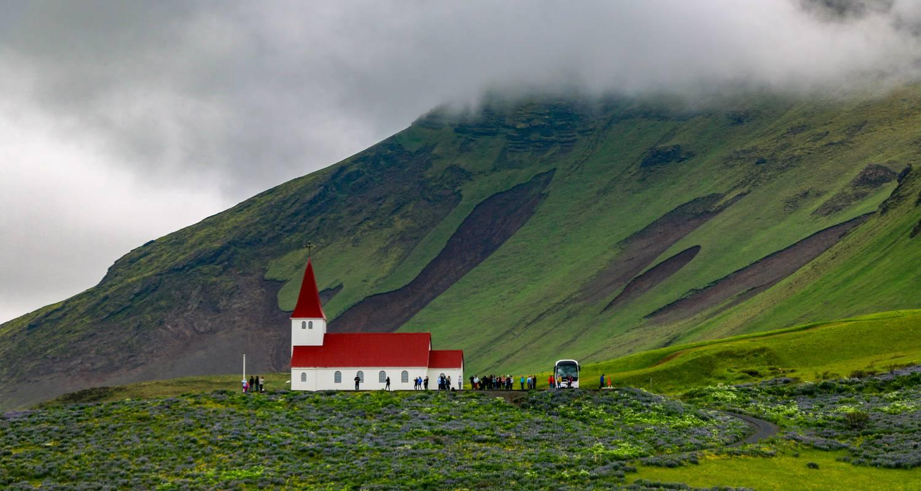



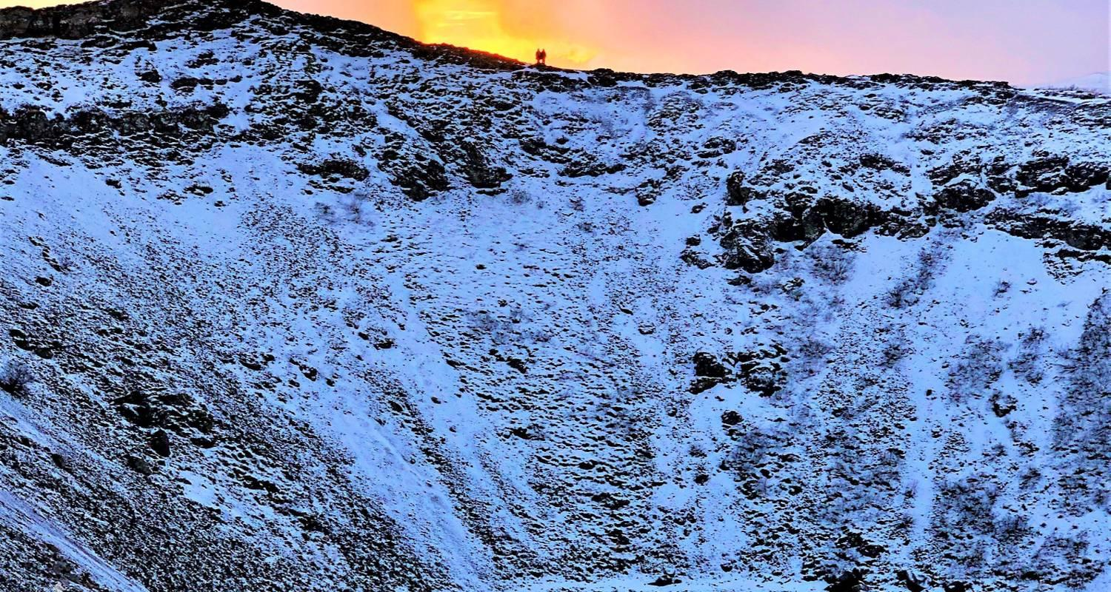

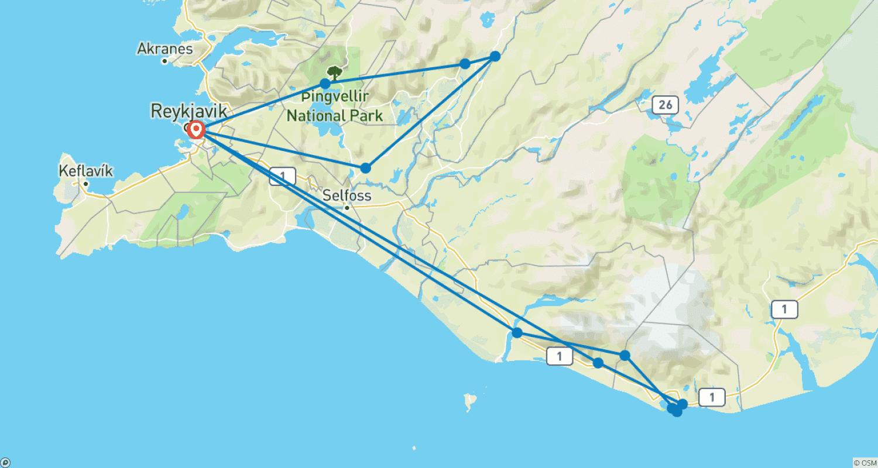

Tour ID: 254546  
Tour Name: 8 Days Westfjords of Iceland

Tour destinations: ['Reykjavik', 'Grábrók Volcano', 'Patreksfjordur', 'Hnjotur', 'Latrabjarg', 'Isafjordur', 'Holmavik', 'Budardalur', 'Hraunfossar']

Tour destinations images:

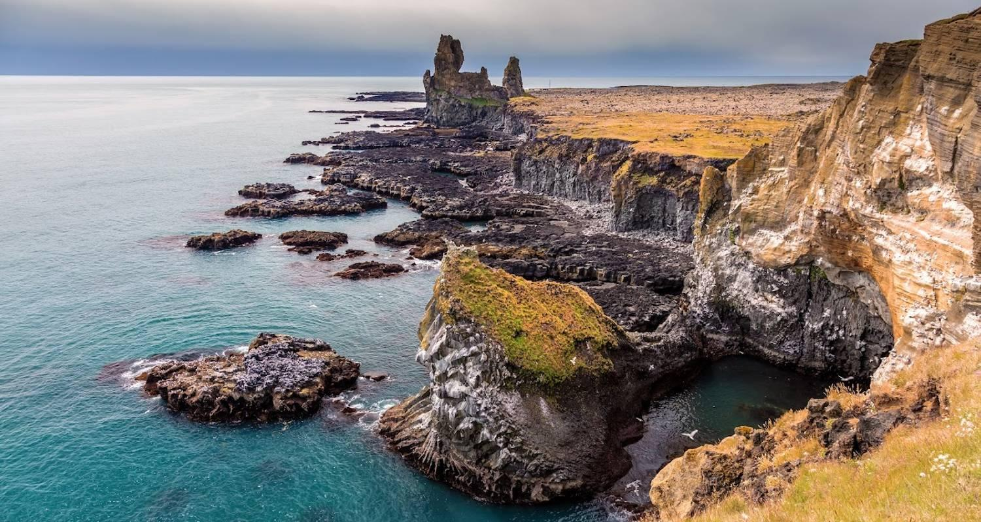

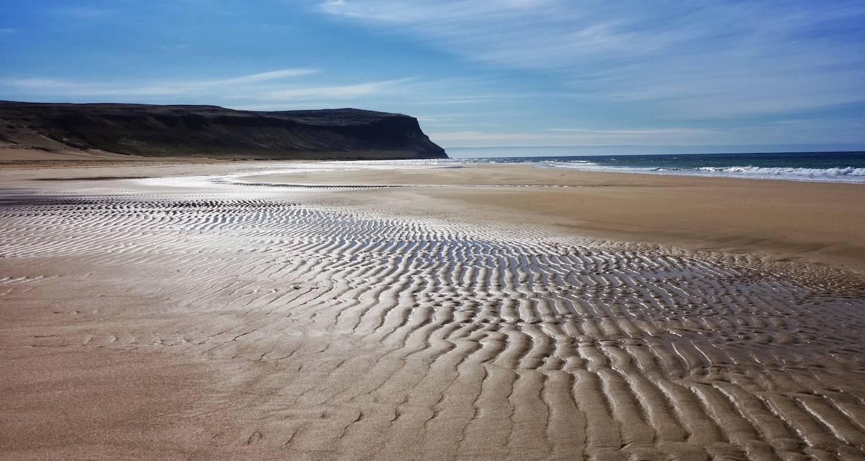

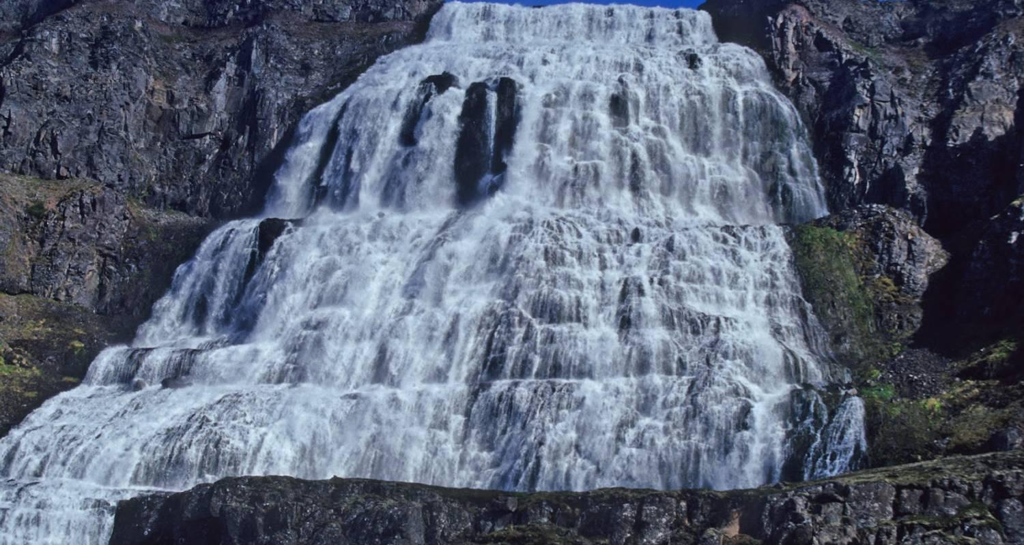

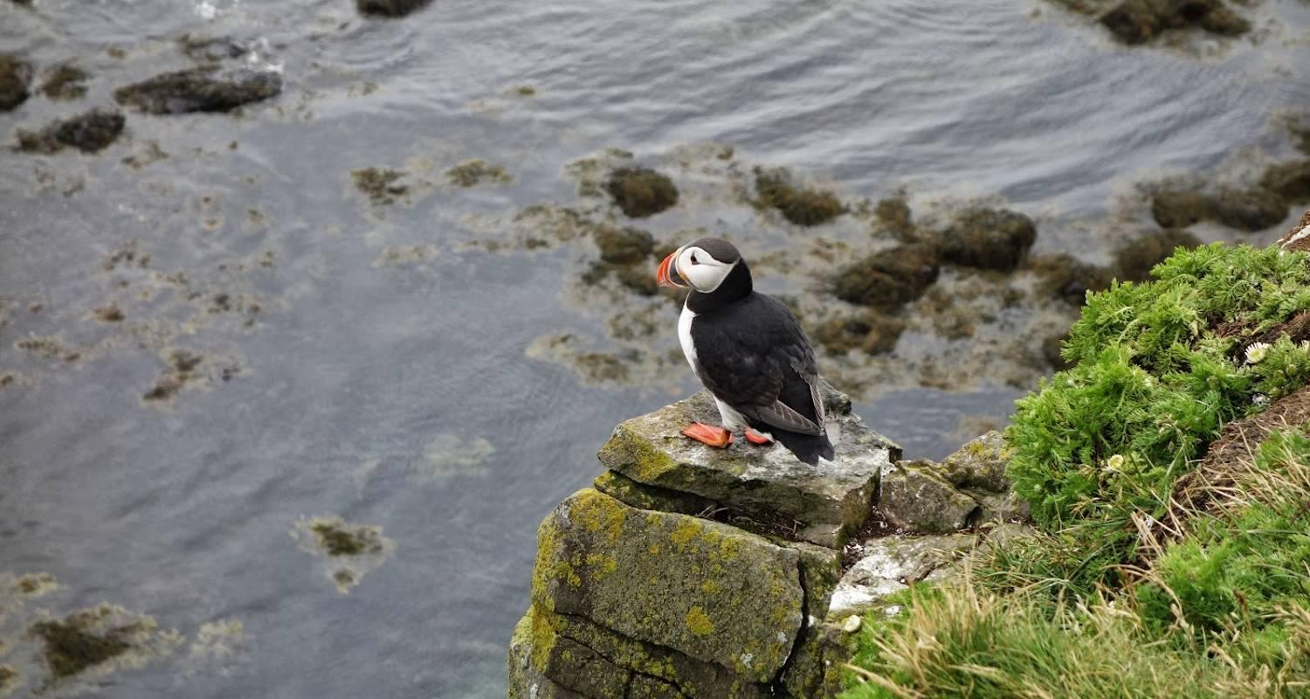

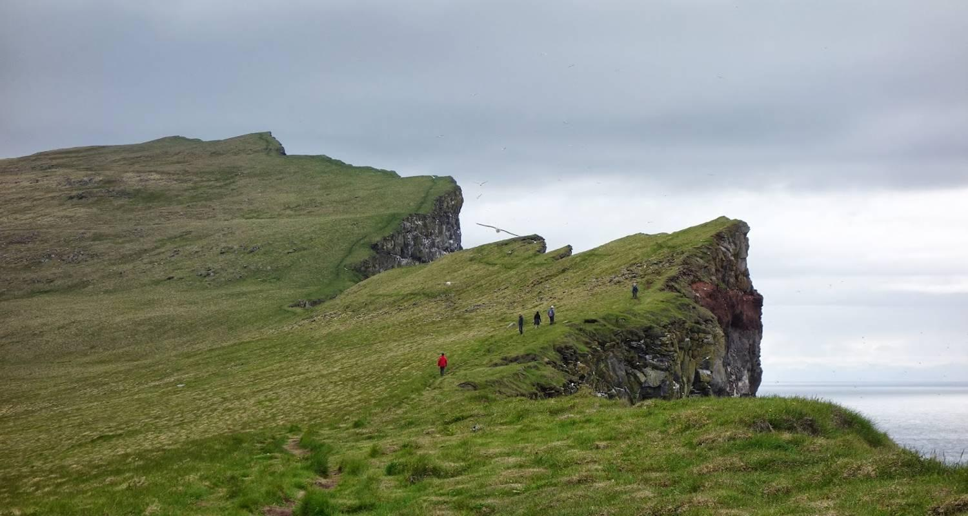

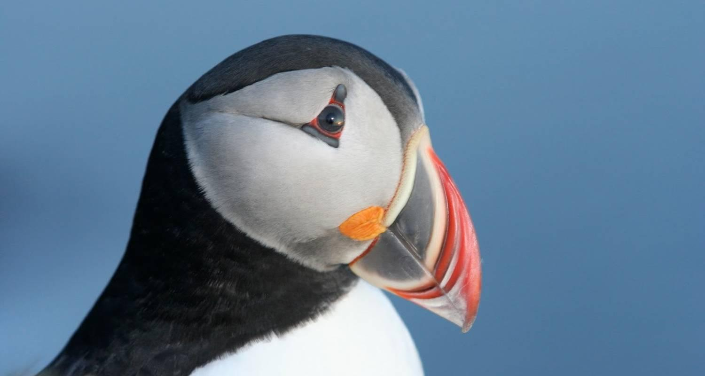

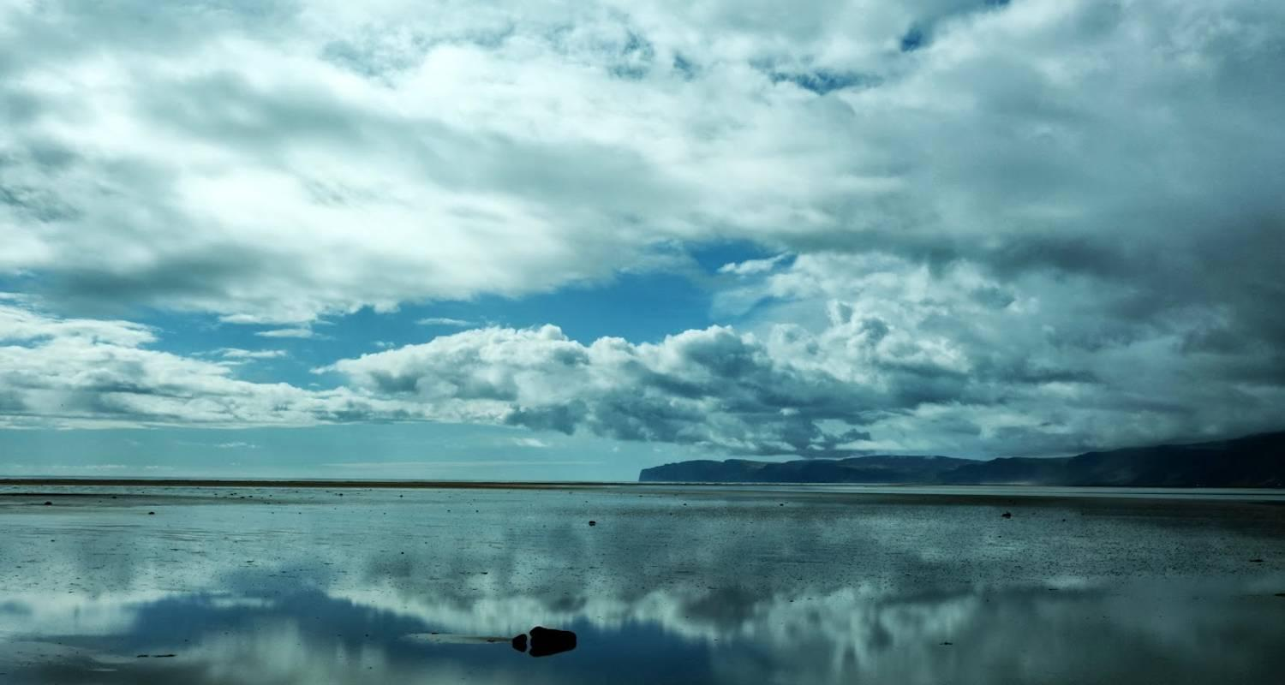

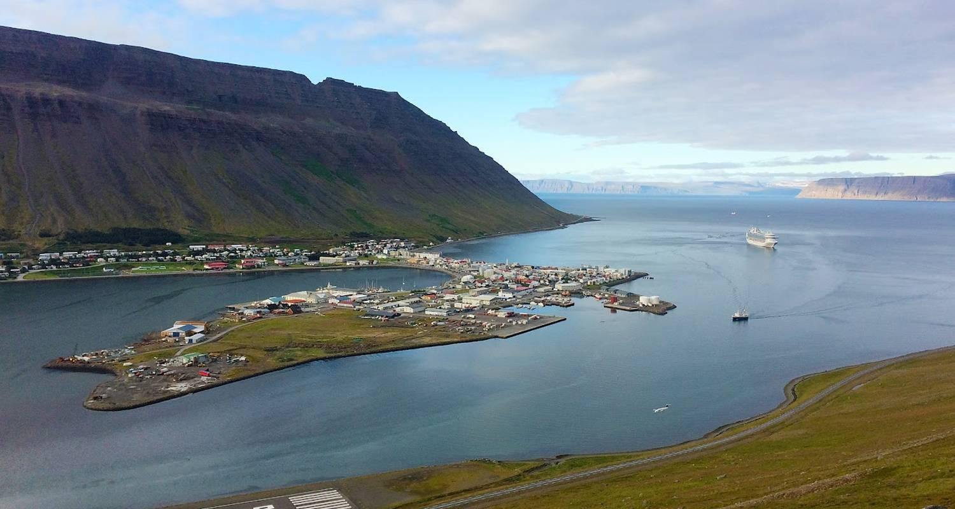

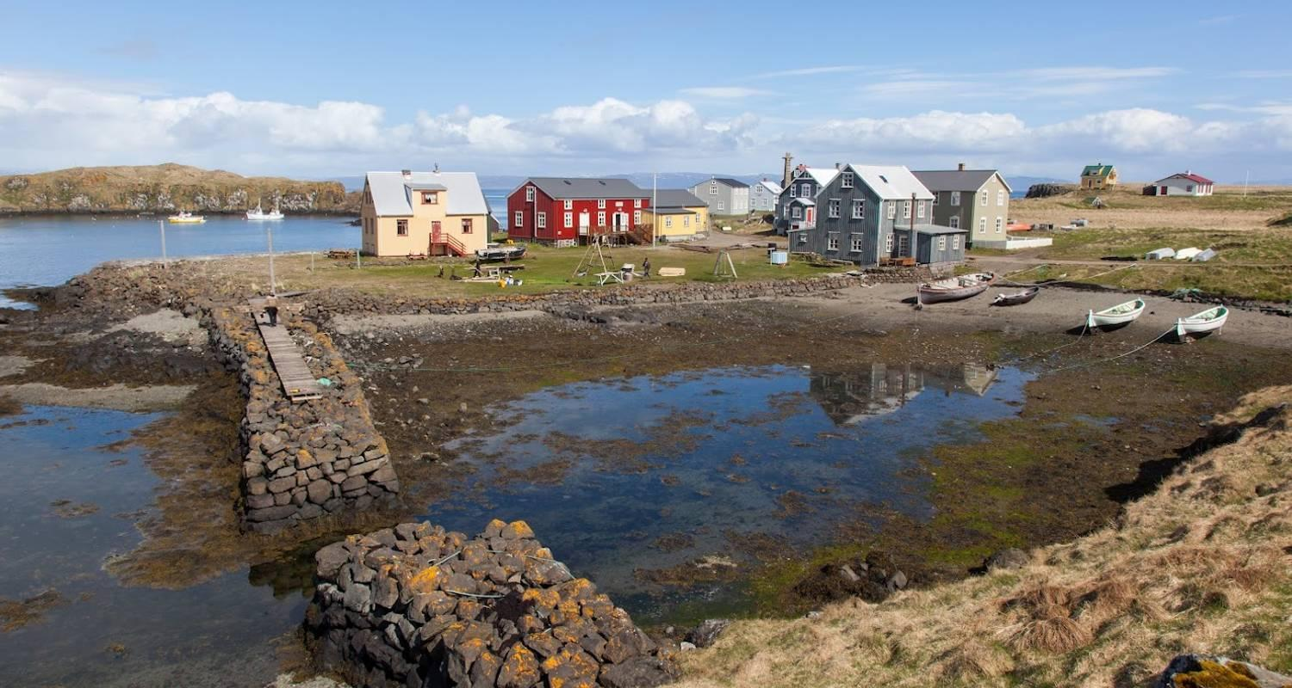

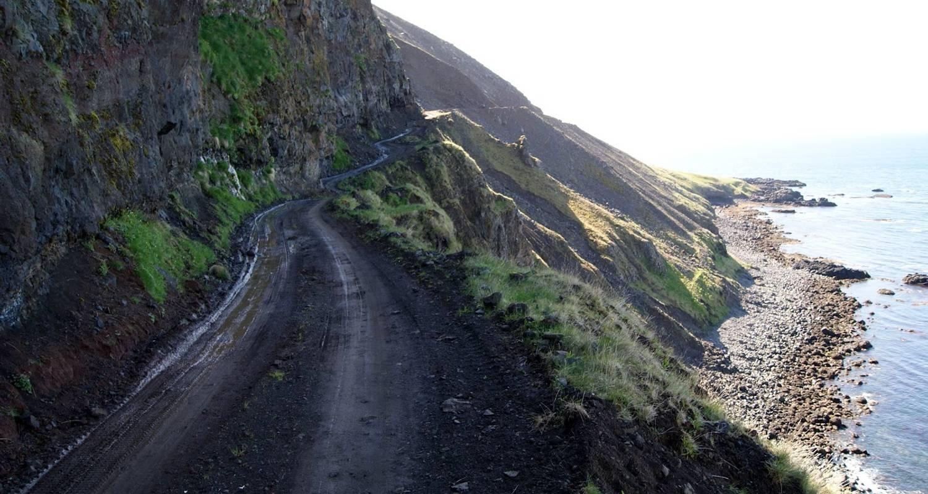

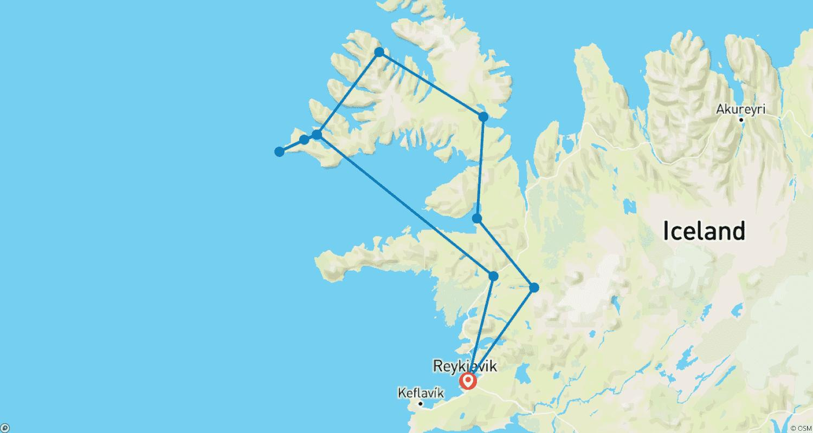

Tour ID: 254648  
Tour Name: 3 Day Best of Iceland Package

Tour destinations: ['Reykjavik', 'Thingvellir National Park', 'Geysir', 'Gullfoss', 'Kerid Volcano', 'Skogafoss', 'Vik', 'Reynisfjara', 'Reynisdrangar Cliffs', 'Solheimajokull', 'Seljaland', 'Hvolsvollur', 'Borgarnes', 'Grundarfjordur', 'Kirkjufell Mountain', 'Snaefellsjokull National Park', 'Djupalonssandur', 'Arnarstapi']

Tour destinations images:





